PeopleSoft
Subsystem Reconciliation
Procedures

Accounts Payable
PeopleSoft System
FINANCIAL SYSTEMS

PeopleSoft Financials for Public Sector v9.0
Fall 2008
Introduction
Reference the Accounts Payable High Level Overview of AP Data Flow (Diagram)

The Trial Balance (GL###044M) will be used as the main report to which each agency will reconcile. Data on the Trial Balance is comprised of data from journals that were either entered directly in the General Ledger or via one of the sub-modules (AP, AR & AM). Open encumbrances are also displayed on the Trial Balance.

Introduction

The purpose of this training exercise is to familiarize you with the various reports, steps, and account ranges that need to be used when balancing the Accounts Payable sub ledger to the General Ledger monthly. What actual accounts you use will depend on your agency.

The overall objective is to verify that all data input and posted in all sub-modules are also posted in the General Ledger by performing the following verification and or reconciliation:

- Compare all expense account number entries in (AP, AR & other journals) to expenses in the General Ledger
- Compare outstanding payables in AP to outstanding payables in the General Ledger
- Compare travel expenditures in AP to the Travel Report
- Compare per diem expenditures in AP to the Per Diem Report

This reconciliation should be performed on a monthly basis in order to facilitate the year end reporting required CAFR. The general idea is to ensure that all Accounts Payable activities in the Accounts Payable module are reflected in the Trial Balance.

****Several reports and queries will be used for reconciliation, below is an example of how reports will be listed throughout this document and where the report ids are located.****

EXAMPLE: Report – GLS4042X -- GL###044M -- Trial Balance Detail Report

- ‘Report’ – indicates if the document is a report or query
- ‘GLS4042X’ – indicates the process name that appears in PeopleSoft’s process scheduler – see illustration on the next page.

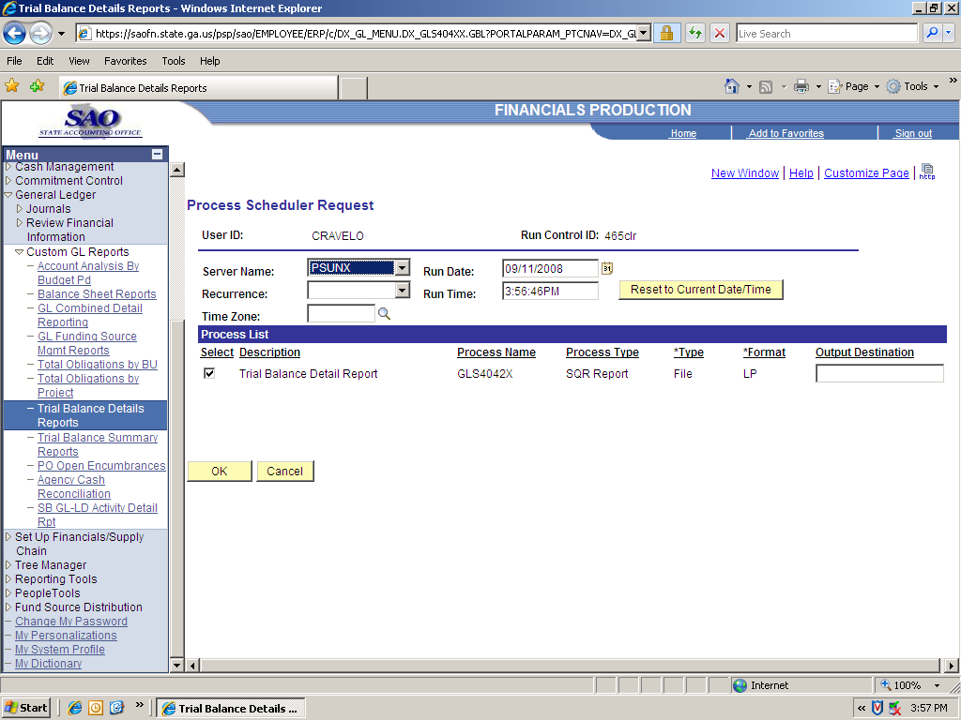

- GL###044M – indicates the report id in Document Direct - see illustration below

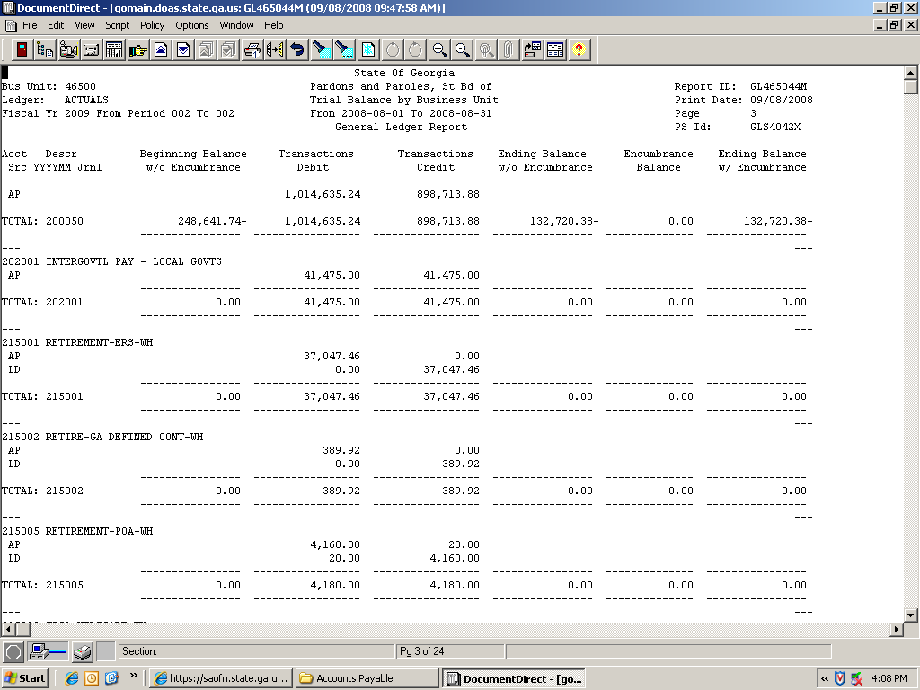

- Trial Balance Detail Report -- indicates a description of the report

Each agency needs to verify that the outstanding payables, expenditures, travel and per diem recorded in Accounts Payable are also recorded in GL on a monthly basis. This is accomplished by performing an analysis of the data, which starts with pulling the following reports and queries:

    - Report – APS4019X – AP###0419 – Travel Report (automatically produced at month end)
    - Report – APS4020X – AP###0420 – Per Diem Report (automatically produced at month end)
    - Report – GLS4042X – GL###044M – Trial Balance Detail Report (automatically produced at month end)
    - Report – APS4003X – AP###0403 – Outstanding Payables by Vendor (automatically produced at month end)
    - Query – 0AP029C_Outstanding Payables by Vendor by accounting period and replaces Report APS4003X – GL###0403 when you are reconciling an extended accounting period or two months open in the same accounting period.
    - Query – 0AP005_VERIFY_EXP Accounts Payable All Expenditures
    - Query – 0AP005K_RECON -- PO_VCHR Accounts Payable Expenditures
    - Query – 0AP005J_RECON – AP data for expense reconciliation
    - Query – 0AR009A_RECON -- AR data for expense recon
    - Query – 0AR009B_VERIFY_REV_OTH – AR Direct Journal data for Travel & Per Diem recon
    - Query – 0GL042_RECON -- Journals entered directly in GL
    - Query – 0GL041_RECON -- Ledger Data AP Recon
    - Query – 0AR008A_VERIFY_REV_CUST – AR Item data for Travel & Per Diem recon
.

The next step instructs you to prepare a pivot table to compare all of your expense entries for your agency to expenses booked in the General Ledger. When your pivot table is complete for the reports listed below, you will be able to quickly see if all expense entries have also posted to the General Ledger as they should all net to zero on the pivot table comparison.

TOTAL EXPENDITURE VERIFICATION:

Object: Compare all appropriate expense account number entries for your agency in (AP, AR & other journals) to expenses in the General Ledger (i.e., all of the appropriate expense accounts for your agency).

Procedure

Compare all expense account number entries in all modules (AP, AR and other journals) to expenses in the General Ledger

- Run queries:
- 0AP005J_RECON -- AP data for expense recon
- 0AR009A_RECON -- AR data for expense recon
- 0GL042_RECON -- Journals entered directly in GL
- 0GL041_RECON -- Ledger Data AP Recon

- Combine results from all four queries into one spreadsheet

- Follow the instructions to Prepare a pivot table

- Analyze data

- Expense account entries compared to GL entries should net to zero

How to run queries and prepare pivot table

- Run queries listed below in preparation for creation of pivot table. Below is a sample of the pivot table results that will be produced from the instructions in Exhibit A.

STEP | SOURCE | ACTION
Step 1:  Run queries and save results as suggested in step 2 of Exhibit A | 0AP005J_RECON AP data for expense recon  0AR009A_RECON AR data for expense recon  0GL042_RECON Jrnls entered directly in GL  0GL041_RECON Ledger Data AP Recon

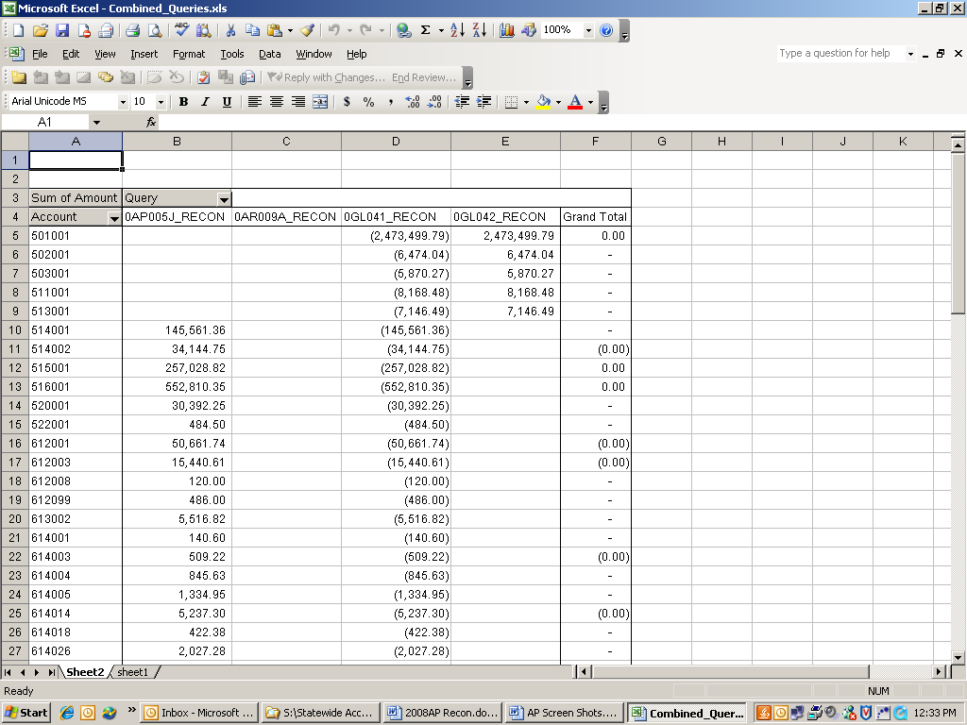

 | Exhibit A
- Navigate to Query Viewer  Reporting Tools > Query > Query Viewer | 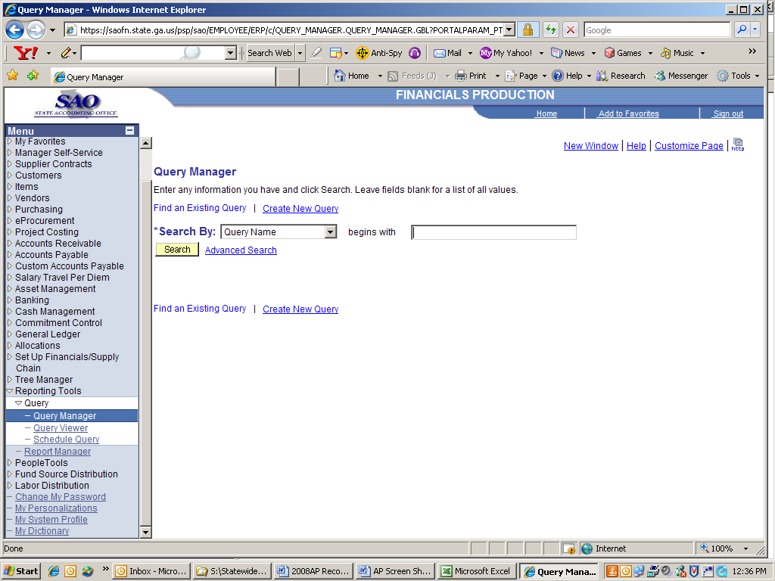
- Run queries and save results with unique names as shown here | For example:
  Query | Name
  0AP005J_RECON AP data for expense recon | AP data
  0AR009A_RECON AR data for expense recon | AR data
  0GL042_RECON Jrnls entered directly in GL | GL jrnl data
  0GL041_RECON Ledger Data AP Recon | Ledger data

 | Exhibit A continued…….
- Combine results of all four queries into one spreadsheet in the following order  - 0AP005J  - 0AR009A  - 0GL042  - 0GL041  For the pivot table to work:  Remove blank lines  Rename amount column  See page 28 for more pivot table instructions. | 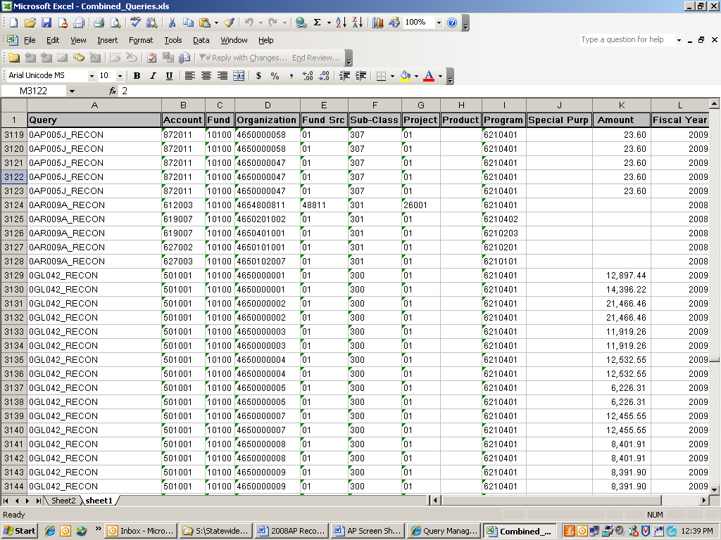
- Navigate to Pivot Table…. menu item | 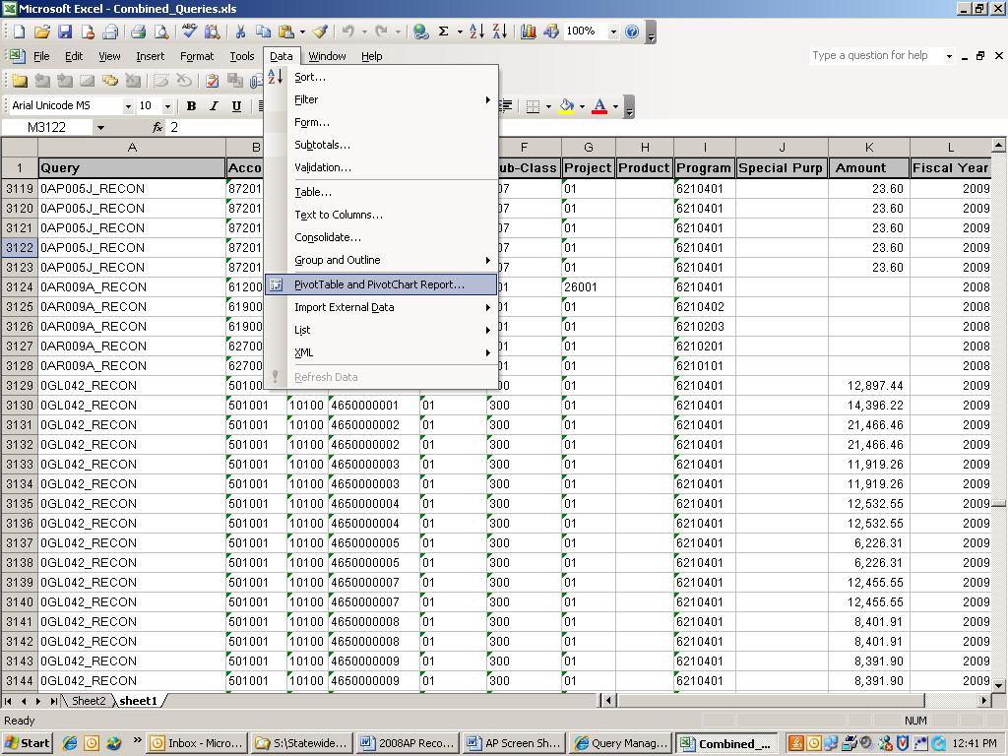

 | Exhibit A continued…….
- Select | 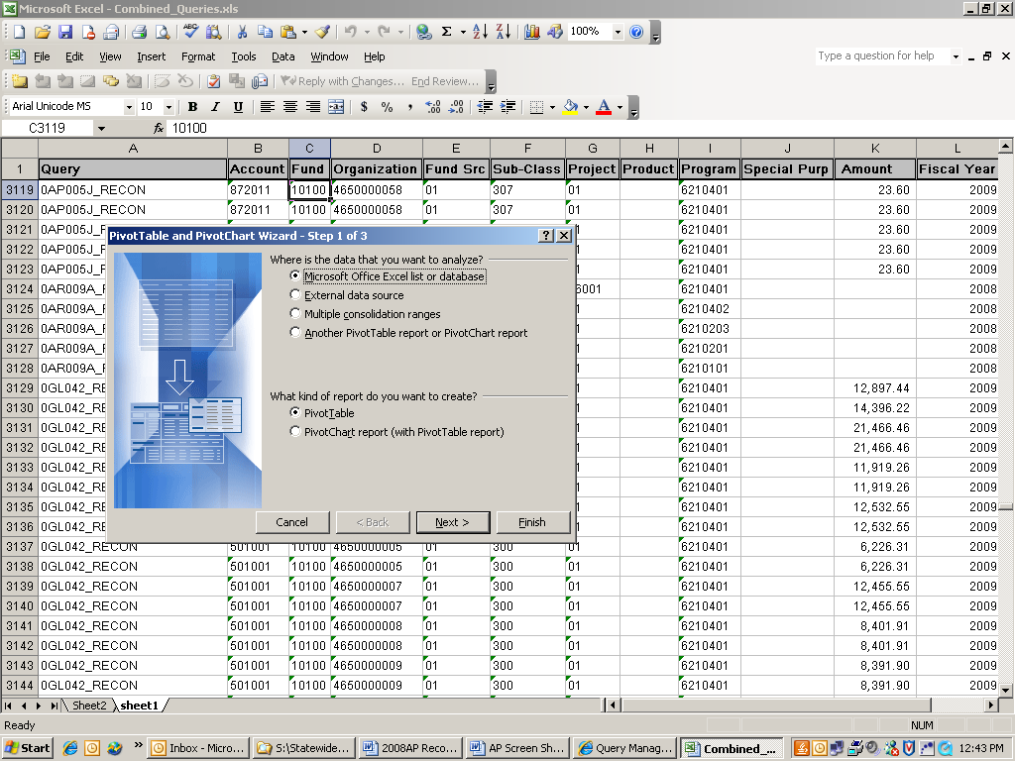
- Step 2 of the Pivot Table wizard will appear with data selected as the range. Select the  button | 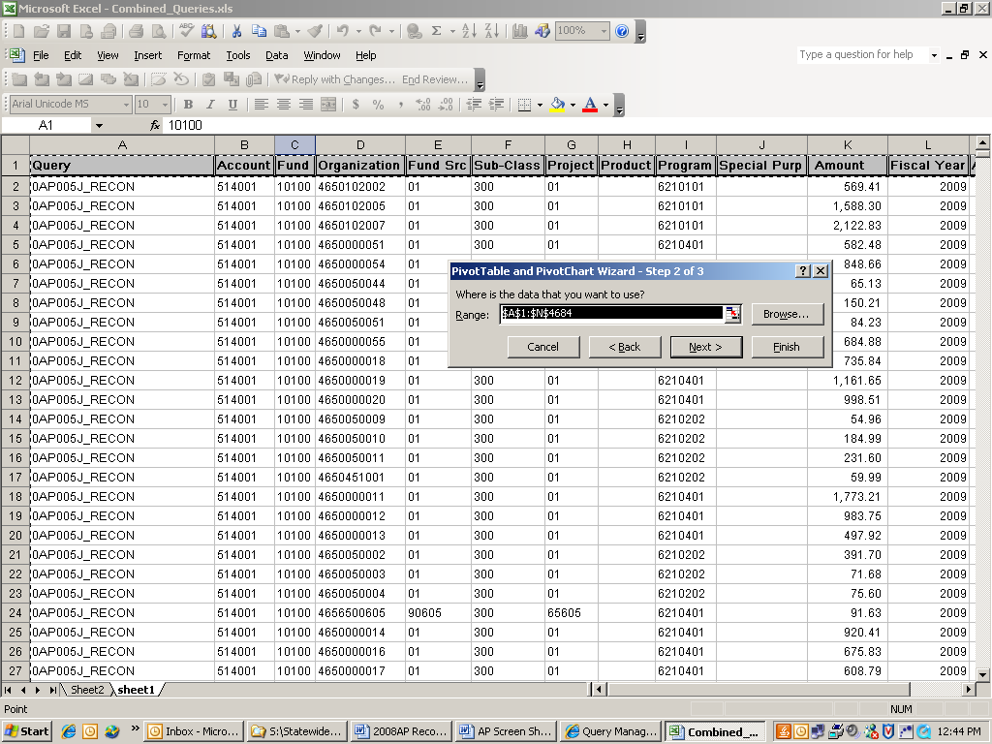

 | Exhibit A continued………………….
- Select | 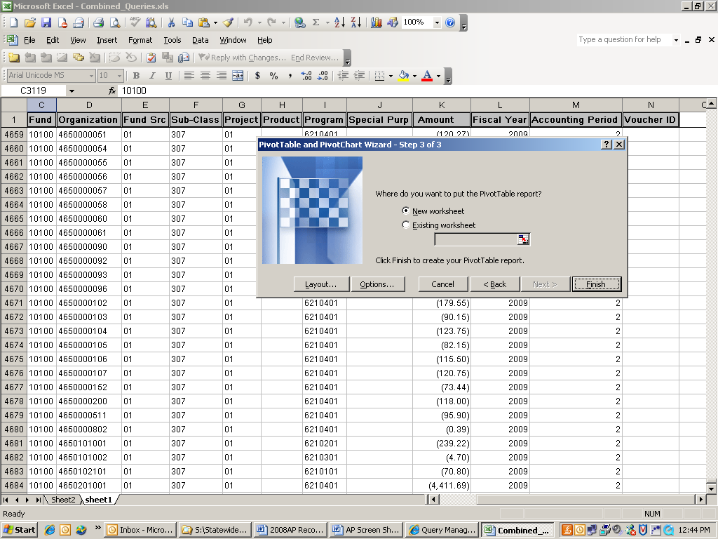
- Drag and drop each field in their appropriate areas; then select  Change “count of amount” to “sum of amount”. | 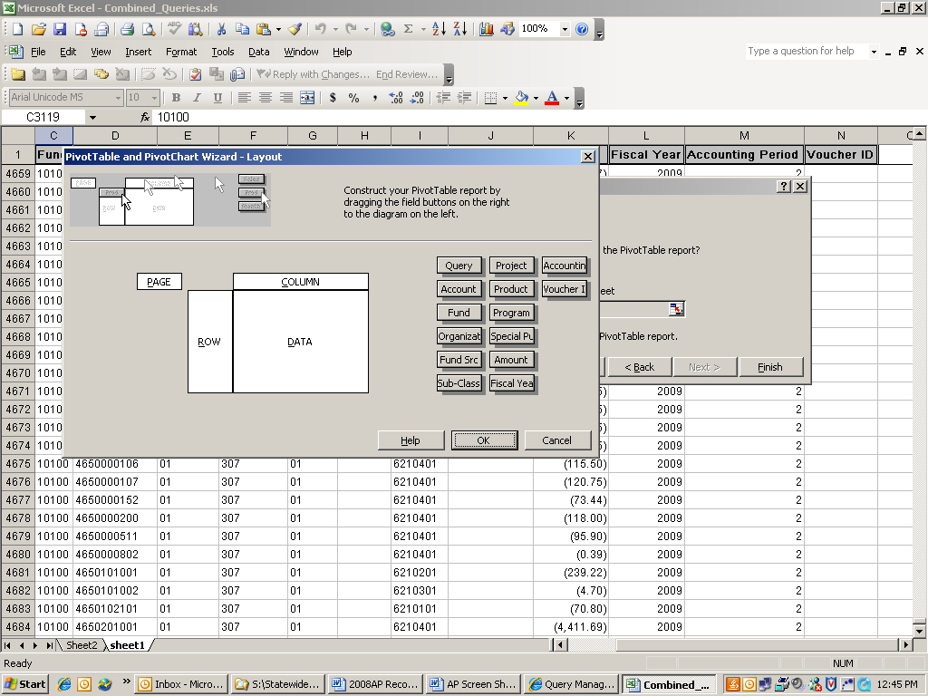

 | Exhibit A continued…….
- Select the button | 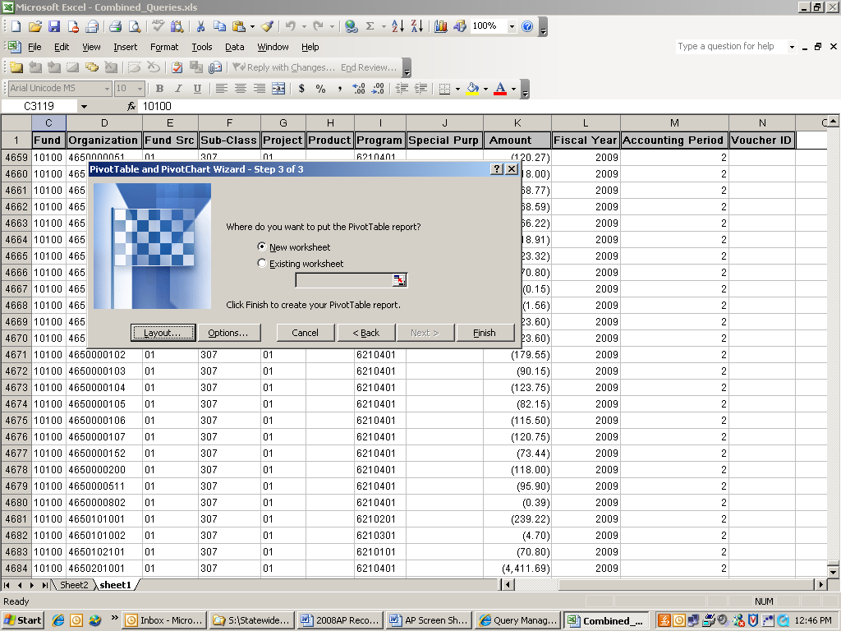

 | Exhibit A continued………………….
- Highlight the amount columns and format them as a number with 2 decimal places | 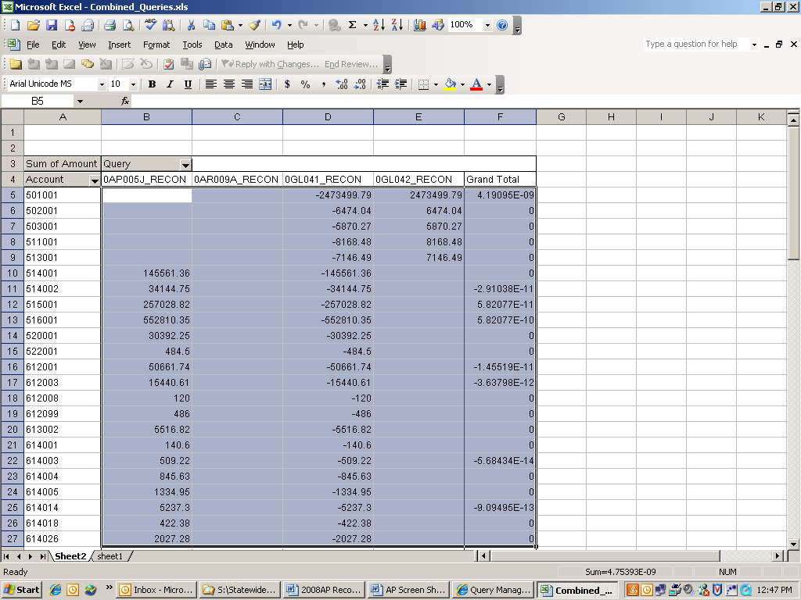
- Sample of pivot table results | 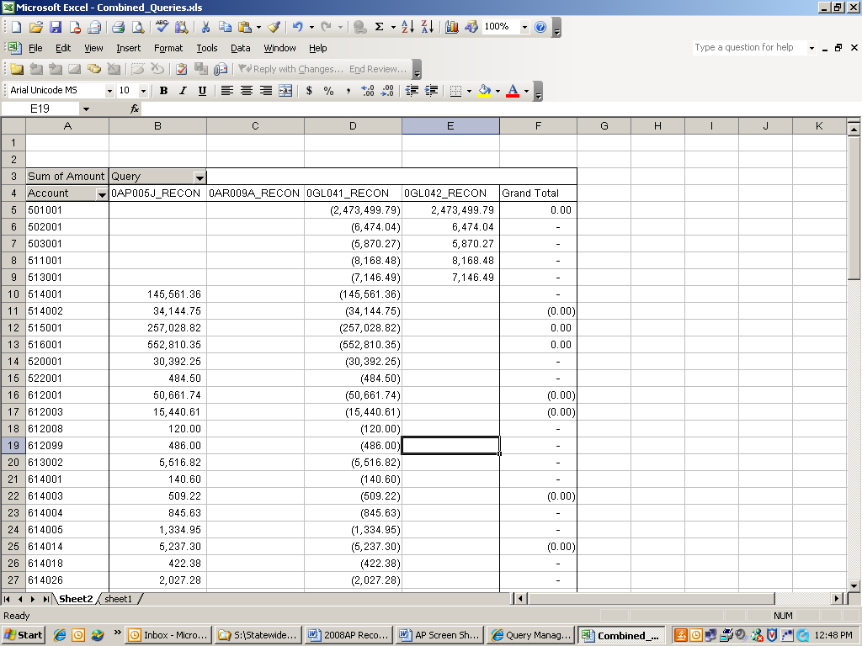

Next you want to reconcile the outstanding Accounts Payable to the balances on the GL Trial Balance report. Please note that if you are reconciling a period that has two months open (extended accounting period) you will need to use an alternate payables report. Example 1 will walk you through the process of reconciling outstanding Accounts Payables for a regular accounting period. Example 2 will show you how to reconcile for an extended accounting period (two months open in the same period).

OUTSTANDING PAYABLE ANALYSIS:

Object: Ensure that balances of liability accounts on the AP outstanding report equals the balances on the Trial Balance

Compare Outstanding Payables in Accounts Payable to Outstanding Payables on the General Ledger

- Run report APS4003X -- AP###0403 – Outstanding Payables by Vendor (automatically produced at month end)

- Run query 0AP029C Outstanding Payables by Vendor by accounting period if reconciling for an extended accounting period. (Two months open in the same accounting period)

- Run report GLS4042X -- GL###044M -- Trial Balance Detail Report (automatically produced at month end)

- Input data from both reports onto analysis sheet

- Analyze data

Example 1 – Regular Accounting Period (Calendar Month) for Outstanding Accounts Payable

- Input the liability account numbers with their corresponding credit/debit balances from the trial balance GL###044M (GLS4042X) -- Trial Balance Detail Report. The Trial Balance Net amount and Variance amount will be calculated automatically.

STEP | SOURCE | ACTION
Step 1:  Obtain liability account balances from General Ledger | GL###044M -- Trial Balance Detail Report -- | Input liability account numbers & balances – Columns A, B, C & D

Example 1 – Regular Accounting Period (Calendar Month) for Outstanding Accounts Payable

- Input liability account numbers with their corresponding balances from the AP###0403 -- Outstanding Payables by Vendor

STEP | SOURCE | ACTION
Step 2:  Obtain liability account balances from Accounts Payable module | AP###0403 -- Outstanding Payables by Vendor | Input liability account numbers & balances – Columns G & H

Note: Sum the liability amounts for each account number and year from the summary section of the AP###0403 report.
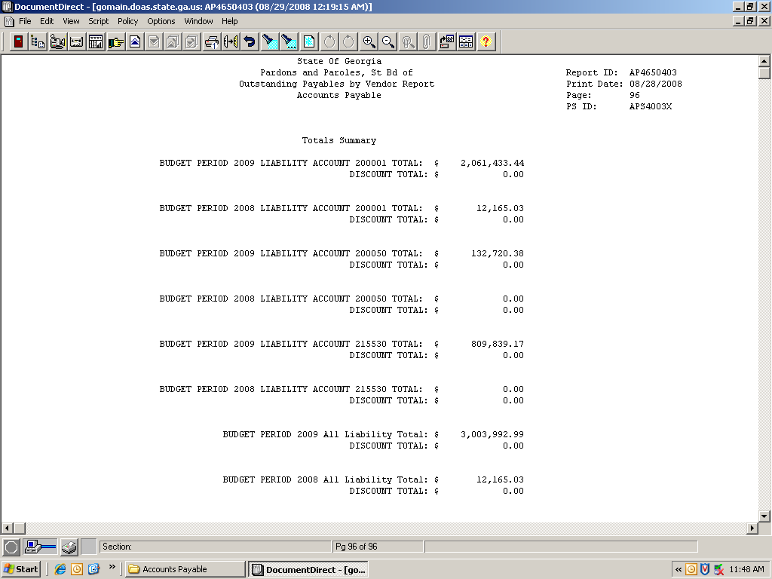

You can see that August Payables were in balance with no variance.

Example 2 – Reconciling an Extended Accounting Period for Outstanding Accounts Payable
- Input the liability account numbers with their corresponding credit/debit balances from the trial balance GL###044M (GLS4042X) -- Trial Balance Detail Report. The Trial Balance Net amount and Variance amount will be calculated automatically.

STEP | SOURCE | ACTION
Step 1:  Obtain liability account balances from General Ledger | GL###044M -- Trial Balance Detail Report -- | Input liability account numbers & balances – Columns A, B, C & D

Replace the AP###0403 -- Outstanding Payables by Vendor with the 0AP029C in column G

Example 2 – Reconciling an Extended Accounting Period for Outstanding Accounts Payable

- Input liability account numbers with their corresponding balances from the 0AP029C (accounts 200001 through 233001) -- Outstanding Payables by Vendor by accounting period. Note: In this example you are reconciling for an extended accounting period (two months open in the same period) you will need to replace the AP###403 with the balances from the 0AP029C (accounts 200001 through 233001). This report picks up outstanding payables by vendor for the accounting period.

STEP | SOURCE | ACTION
Step 2:  Obtain liability account balances from Accounts Payable module | 0AP029C -- Outstanding Payables by Vendor by Period | Input liability account numbers & balances – Column H

Note: Pick up the total liability amounts for each account number from the 0AP029C (accounts 200001 through 233001) report. You can pull this report by individual account number or run a consolidated report including all of the Accounts Payable account numbers in the query request. When you put the query in the pivot table you can set it to sort by totals by account number. 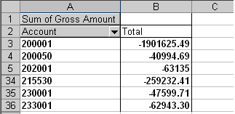

Common reasons why the Trial Balance Report differs from the Outstanding Payable by Vendor Query:
Issue | Resolution/Comments
Accounts Payable transaction(s) not journal generated | Ensure that the journal generation process runs successfully before production of the Trial Balance and Outstanding Payables by Vendor query
Accounts Payable journal(s) not posted in General Ledger | Ensure that all Accounts Payable journals were successfully posted in the General Ledger prior to producing the Trial Balance and Outstanding Payables by Vendor query
Multiple periods open simultaneously; which results in prior period transactions being entered in current period | In the PeopleSoft 9.0 environment, you will only have multiple periods open twice annually. Once for the Federal year end in September and the other for the June year end for the State. A query has been created that will capture the correct payables by vendor for the two defined extended accounting periods. (0AP029C)
Split Payment. | Typically this happens when one converts a PO to a voucher but only pays a portion of the voucher. E.g. PO #1234 for $500 was converted to a voucher, but only $200 of the voucher was paid

After you have verified that your outstanding Accounts Payables are in balance with the General Ledger, you need to do the same thing for travel and per diem expenses.

TRAVEL RECONCILIATION:

Objective: To ensure that all travel expenditures entered via Accounts Payable, Accounts Receivable, and General Ledger are captured in the Trial Balance. NOTE: Travel expenditures entered via Purchasing will be analyzed separately.

It is imperative that the travel amounts on the Trial Balance be verified as these amounts will be subject to specific audit review.

AP###0419 shows all travel expenditures by employee and a summary by account number and module (AP, AR & PO).

Note: The ‘AP’ amount on APS4019X -- AP###0419 – Travel Report only includes vouchers directly entered in Accounts Payable; it does not include vouchers created from Purchase Orders. Per specific request from Auditors…“all travel expenses entered via a Purchase Order should be reflected on the report as coming from the ‘PO’ module”.

      - Compare travel expenses in Accounts Payable to travel expenses in the General Ledger

        - Run reports:
- Report – GLS4042X -- GL###044M -- Trial Balance Detail Report (automatically produced at month end)
- Query -- 0AP005K_RECON -- Accounts Payable Expenditures from PO VCHRs
- Query -- 0AR008A_VERIFY_REV_CUST – AR Item data for Travel & Per Diem recon
- Query -- 0AR009B_VERIFY_REV_OTH – AR Direct Jrnl data for Travel & Per Diem recon
- Report – APS4019X -- AP###0419 – Travel Report {automatically produced at month end)

        - Input data from reports and queries onto analysis sheet

        - Analyze data

STEP
SOURCE | ACTION
Step 1:  Obtain ALL travel expense account (640xxx) balances from General Ledger | GL###044M -- Trial Balance Detail Report -- | Input ALL travel account balances for each module  – Columns A, B, C & D

Note 1: The AP travel amount on the Trial Balance includes both direct vouchers entered in Accounts Payable and vouchers created from Purchase Orders.
AP travel amounts on AP###0419 Travel Expense Report do not include vouchers associated with Purchase Orders.
The 0AP005K query shows the voucher amounts entered in Accounts Payable via Purchase Orders
Note 2: Amounts with source ‘PO’ on the AP###0419 & AP###0420 are for informational purposes as requested by the Auditor General Office. Consequently, you should NOT enter amounts with source ‘PO’ to the analysis sheet. Another reason for not entering amounts with source ‘PO’ to the analysis sheet is that there are no corresponding PO line item amounts on the Trial Balance to compare.

Note 3: Do not include any prior year amounts from the Trial Balance as they are not included on the Travel Expense and Per Diem Reports.

- Input travel account numbers with their corresponding balances from the reports and queries listed below

STEP | SOURCE | ACTION
Step 2:  Obtain ALL travel expense account (640xxx) balances from all modules (PO; AP; AR; GL) | AP###0419 – Travel Report  0AP005K- RECON -- PO_VCHR  0AR008A – VERIFY_REV_CUST  0AR009B VERIFY_REV_OTH | Input travel balance for each account by module. See Exhibit B for details on how to run 0AP005K query  – Columns G, H, I & J

Common reasons why the Trial Balance Report differs from the Travel Report:
Issue | Resolution/Comments
Balances from PO module are not displayed on the Trial Balance | Travel expenditures entered via Purchase Orders will not be identified on the Trial Balance as PO data.
Accounts Payable journals not posted in General Ledger | Ensure that all Accounts Payable journals were successfully posted in the General Ledger prior to producing the Trial Balance and Outstanding Payables by Vendor query

PER DIEM RECONCILIATION

Objective: To ensure that all per diem expenditures entered via Accounts Payable, Accounts Receivable, and General Ledger are captured in the Trial Balance. NOTE: Per Diem expenditures entered via Purchasing will be analyzed separately.

It is imperative that the per diem amounts on the Trial Balance be verified as these amounts will be subject to specific audit review.

Compare per diem expenses in Accounts Payable to per diem expenses in the General Ledger

- Run reports:
- Report – GLS4042X -- GL###044M -- Trial Balance Detail Report (automatically produced at month end)
- Query -- 0AP005K_RECON -- Accounts Payable Expenditures from PO VCHRs
- Query -- 0AR008A_VERIFY_REV_CUST – AR Item data for Travel & Per Diem recon
- Query -- 0AR009_VERIFY_REV_OTH – AR Direct Jrnl data for Travel & Per Diem recon
- Report – APS4020X -- AP###0420 – Per Diem Report (automatically produced at month end)

- Input data from both reports and queries onto analysis sheet

NOTE 1 : If 0AP005K_RECON has 15 or more rows you have the option of using Exhibit B to summarize the query results by account numbers. This will facilitate transfer of data from the query results to the analysis sheet.
NOTE 2 : Do not include any prior year amounts from the Trial Balance. They are not included on the Travel Expenses and Per Diem Reports.
- Analyze data

- Input per diem account figures along with their corresponding balance from the Trial Balance GL###044M (GLS4042X-- Trial Balance Detail Report). The Trial Balance Net amount, AP###0420 Net amount, and Variance amount will be calculated automatically.

STEP | SOURCE | ACTION
Step 1:  Obtain ALL per diem expense account (651XXX, 652XXX, & 852XXX, 852XXX) balances from General Ledger | GL###044M -- Trial Balance Detail Report -- | Input ALL per diem account balances for each module  – Columns A, C & D

- Input Per Diem account numbers with their corresponding balances from the reports and queries listed below

STEP | SOURCE | ACTION
Step 2:  Obtain ALL per diem expense account (651xxx; 652xxx & 851XXX, 852XXX balances from all modules (PO; AP; AR; GL) | AP###0420 – per diem  0AP005K- RECON -- PO_VCHR  0AR008A – VERIFY_REV_CUST 0AR009B VERIFY_REV_OTH | Input per diem balance for each account by module. See Exhibit B for details on how to run 0AP005K query  – Columns F, G, H & I

Example of how to run a public query in PeopleSoft and create a pivot table from the query using the Per Diem vouchers associated with POs Query 0AP005K. This query is used in the Per Diem balancing spreadsheet above.

 | Exhibit B
- Navigate to the Query Manager

Reporting Tools > Query > Query Manager
- Input the query name ‘0AP005K’ and select  - Select the ‘Excel’ hyper-link to send result to excel workbook | 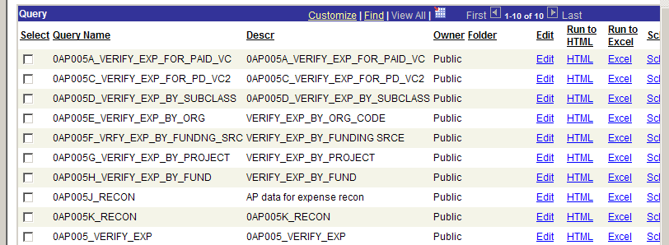

.

 | Exhibit B continued………………….
- Insert the appropriate parameter values and select | 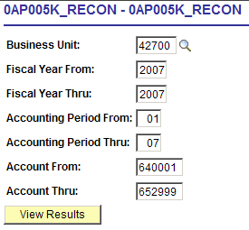  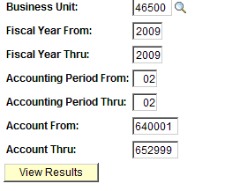
- Select the  button from the file download dialog box | 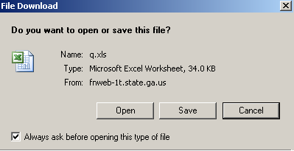

 | Exhibit B continue………………….
- Click the button from the download complete dialog box | 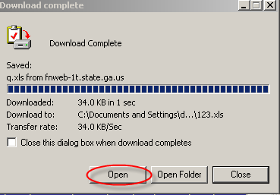

 | Appendix A continued………………….
- Navigate to the query result, select and delete row #1;  Before  After | 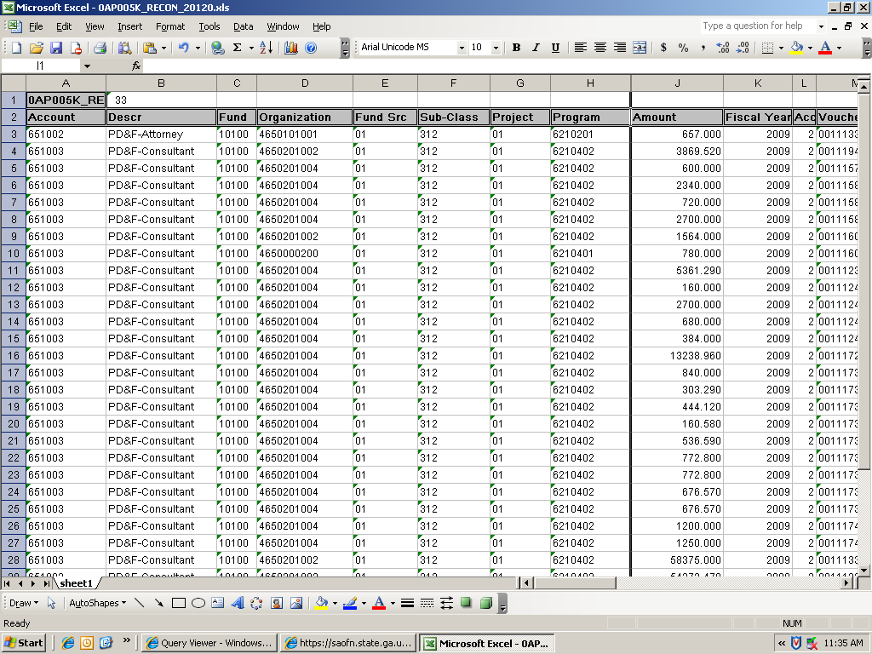  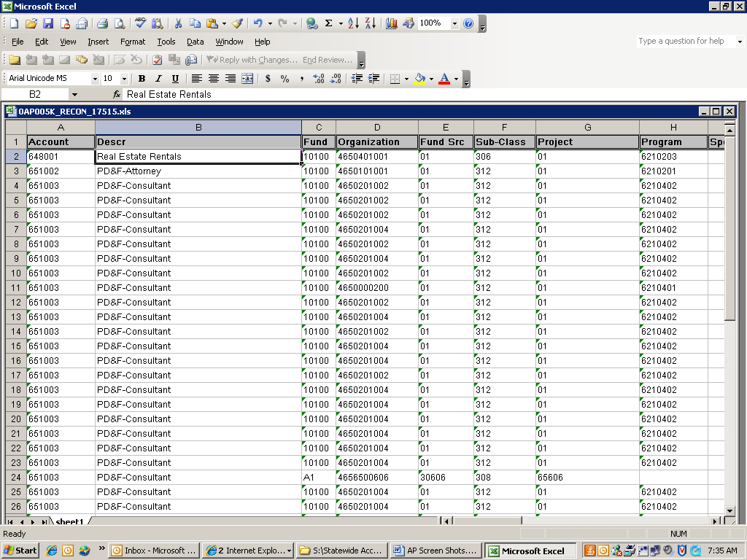
- Format the amount column as number with 2 decimals | 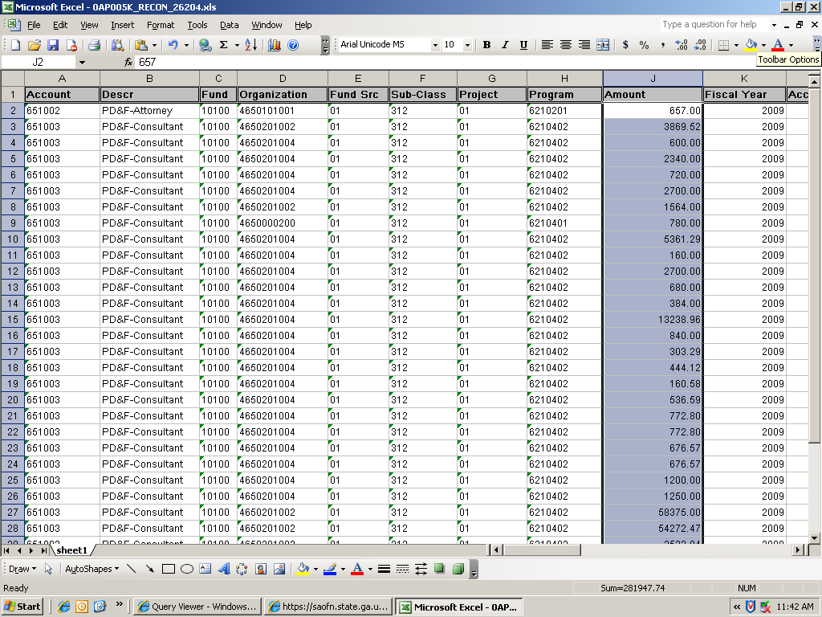

 | Exhibit B continued………………….
- Navigate to the Pivot Table…. menu item | 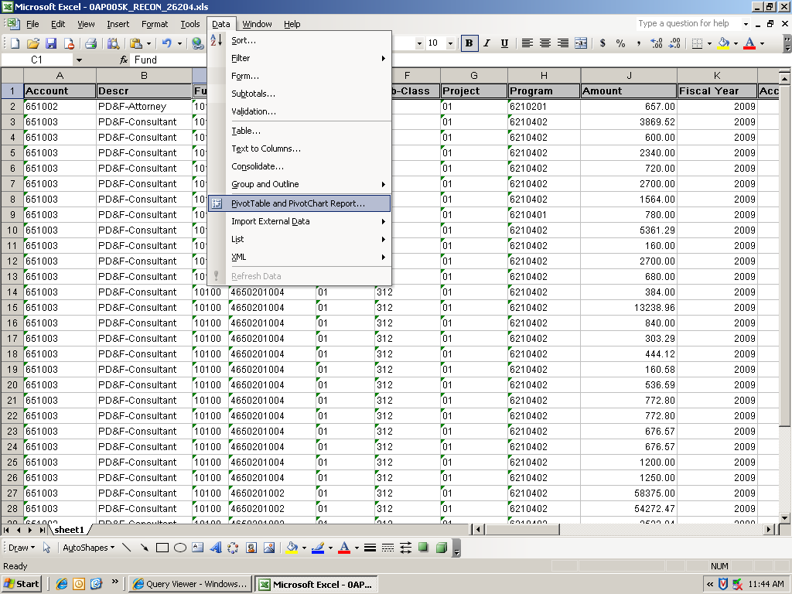
- Select | 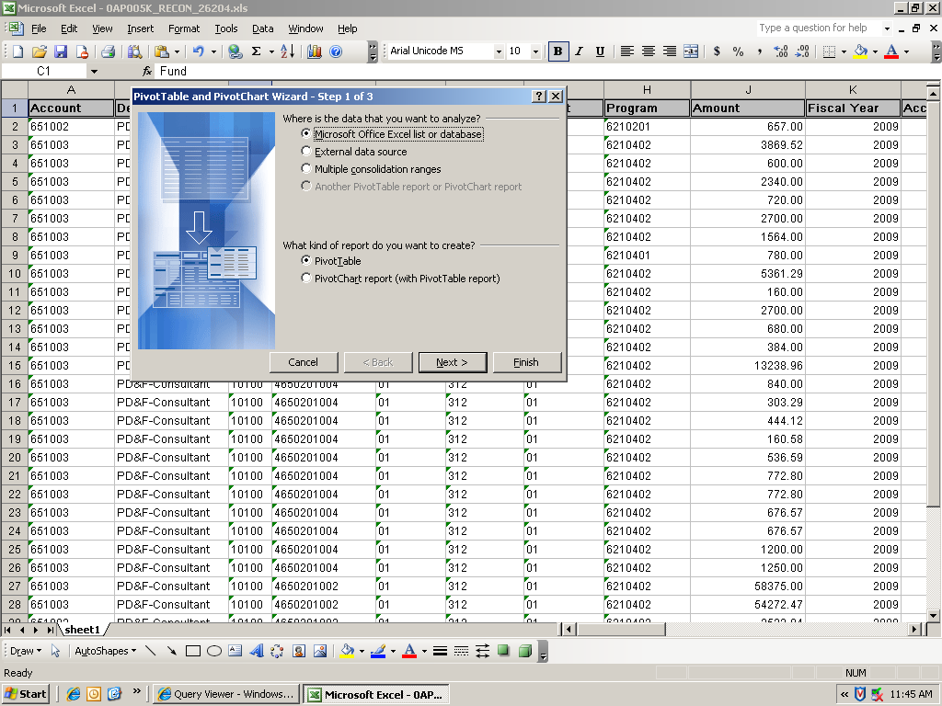

 | Exhibit B continued………………….
- Step 2 of the Pivot Table wizard will appear with data selected as the range. Select the  button | 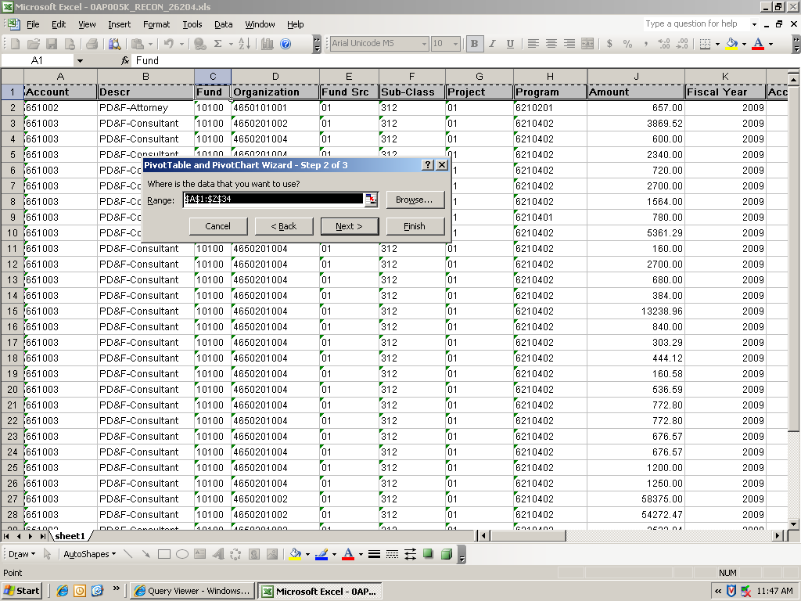
- Select ‘Layout’ | 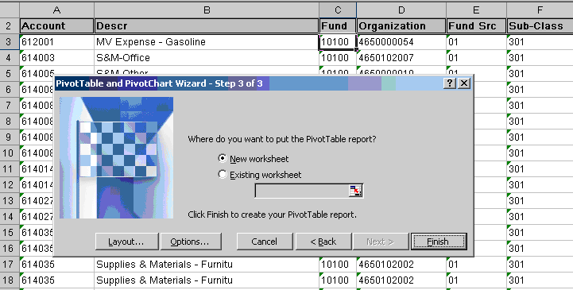
- Drag and drop ‘Account’ field into the ‘Drop Row Fields Here’ area | 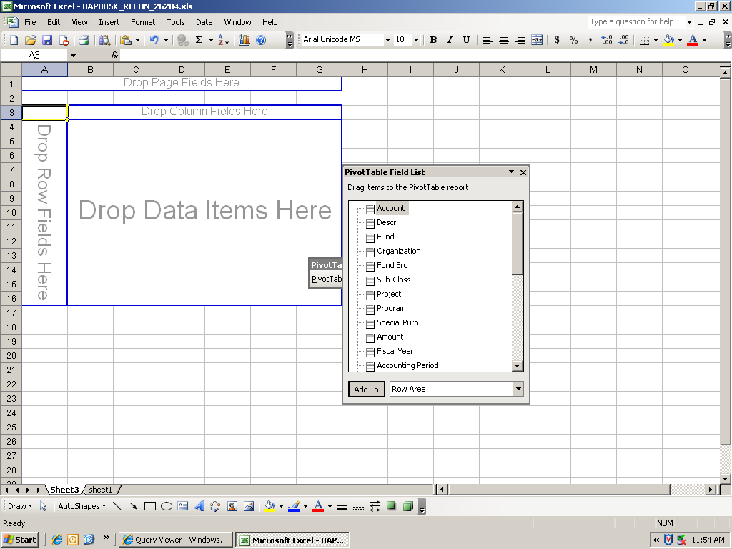
 | Exhibit B continued………………….
- Select Drag and drop ‘Descr’ field into the ‘Drop Row Fields Here’ area | 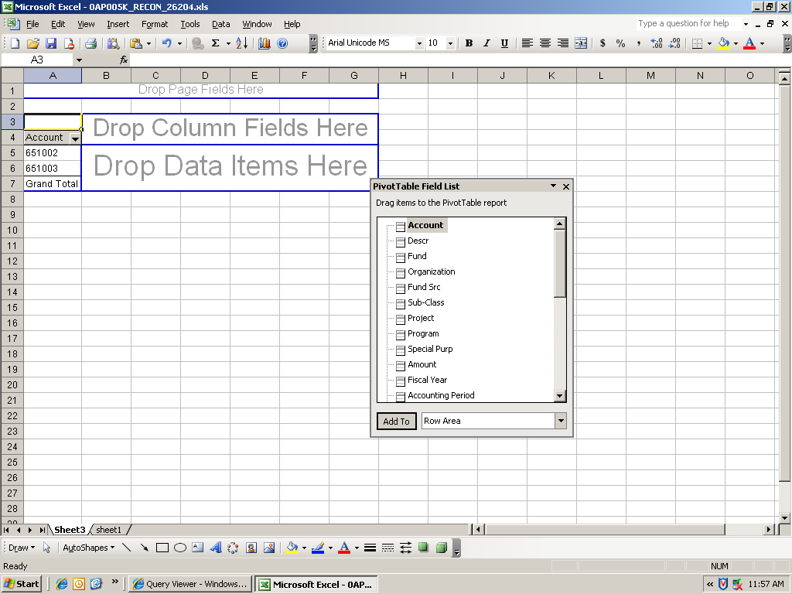
 | Exhibit B continued………………….
- Drag and drop ‘Amount’ field into the ‘Drop Data Items Here’ area | 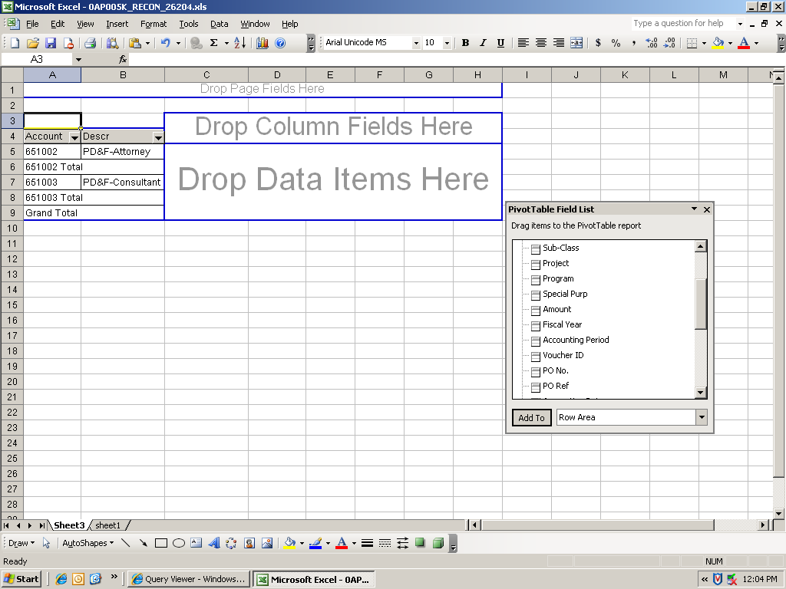
 | 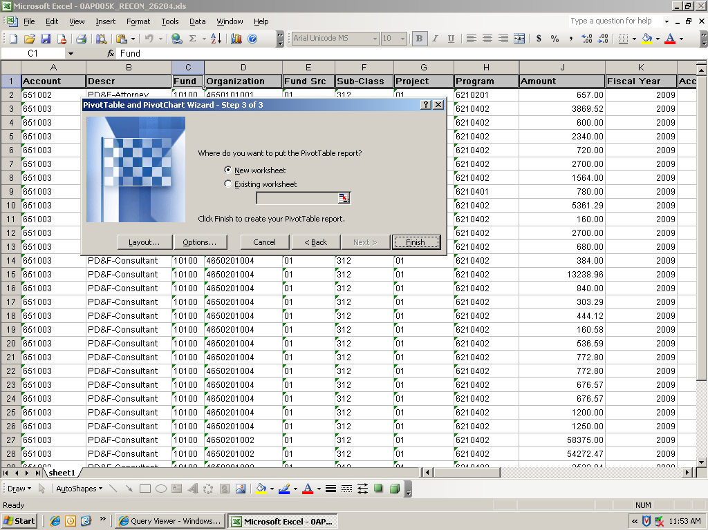
- Result of pivot table | 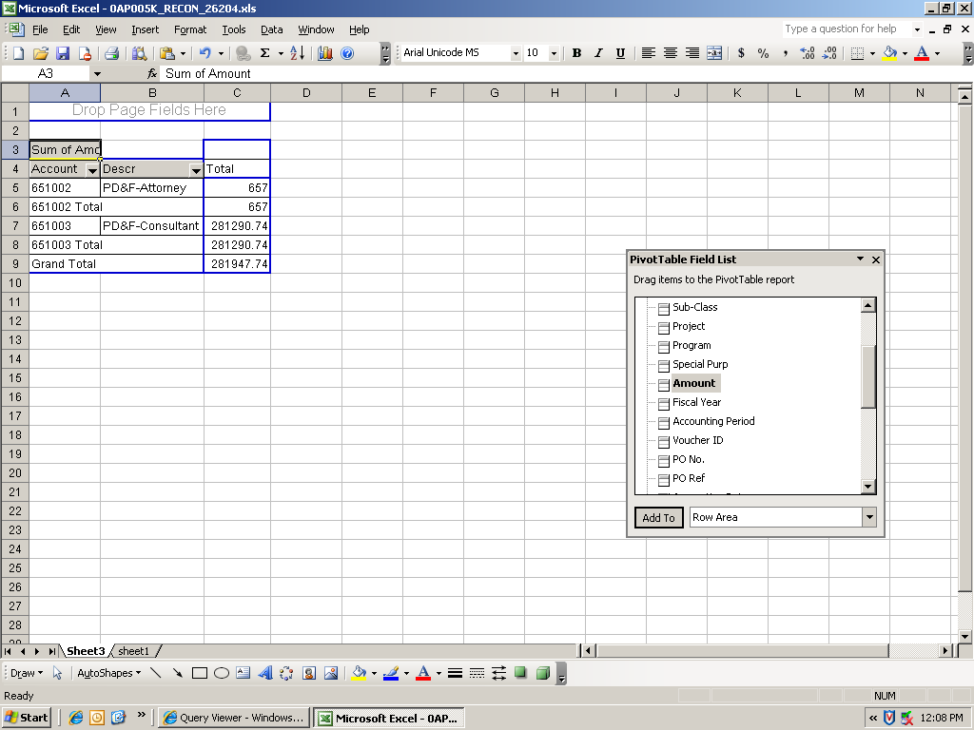

Common reasons why the Trial Balance Report differs from the Per Diem Report:
Issue | Resolution
There is a variance between the two sets of data being compared. | - Try to identify the chartfield combination you are having an issue with  - Run a combined detail for the chartfield combination identified in step 1, along with the period and year in question

