PeopleSoft
Encumbrance/Purchase Order
Reconciliation Procedures

PEOPLESOFT SYSTEM
FINANCIAL SYSTEMS

P E O P L E S O F T F I N A N C I A L S F O R P U B L I C S E C T O R V 9.0
Fall 2008

Introduction

The objective of the Outstanding Encumbrance verification procedure is to verify the amount in the ‘Reserved’ account 328001 on the Trial Balance (GL###044M). Simultaneously, the procedure categorizes the outstanding encumbrance data by Budget Period. In addition, the Trial Balance data should tie to the PO module data (any difference is due to an encumbrance entry made directly in the GL module).

How to accomplish objective:

- Run Trial Balance report (GL###044M) and identify balance for account 328001

- Run query 0PO013FP_ENC_THRU_FISCALPERIOD and report GLS4071X -- GL###0471(PO Summary Encumbrance Report). The query gives summarized information by chart-field combination while the report gives detail information for each purchase order. Both query and report balances should be the same. Compare these balances with that of the trial balance, if they do not tie, it should be the result of the following:

Encumbrance journals entered directly into the General Ledger. Data from these journals would be in the General Ledger but not in the Purchasing Module, consequently this would cause an out of balance issue. To determine if this is the issue run query 0PO045_GL_MAN_ENC_JRNL.

These following reports and queries are used in the verification process:

Report – GLS4042X -- GL###044M -- Trial Balance Detail Report

Report – GLS4071X -- GL###0471 – Report lists outstanding encumbrance detail by purchase order distribution line.

Query – 0PO013FP_ENC_THRU_FISCALPEREIOD – Query lists outstanding encumbrance by Budget Period and summarization by chart-field combination (account/fund/dept/fund source/class/project).

Query – 0PO045_GL_MAN_ENC_JRNL – query lists all encumbrance journals entered directly into the General Ledger (Only need to run this, if the above is out of balance).

*****Several reports and queries will be used for reconciliation, below is an example of how reports will be listed throughout this document and where the report ids are located. *****

EXAMPLE: Report – GLS4042X -- GL###044M -- Trial Balance Detail Report

- ‘Report’ – Indicates if the document is a report or query

- ‘GLS4042X’ – Indicates the process name that appears in PeopleSoft’s process scheduler – see illustration below

Process Scheduler Request
Run Control
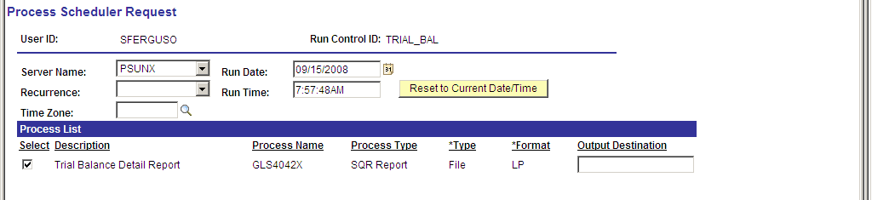

- GL###044M – Indicates the report ID for the out in Document Direct see illustration below
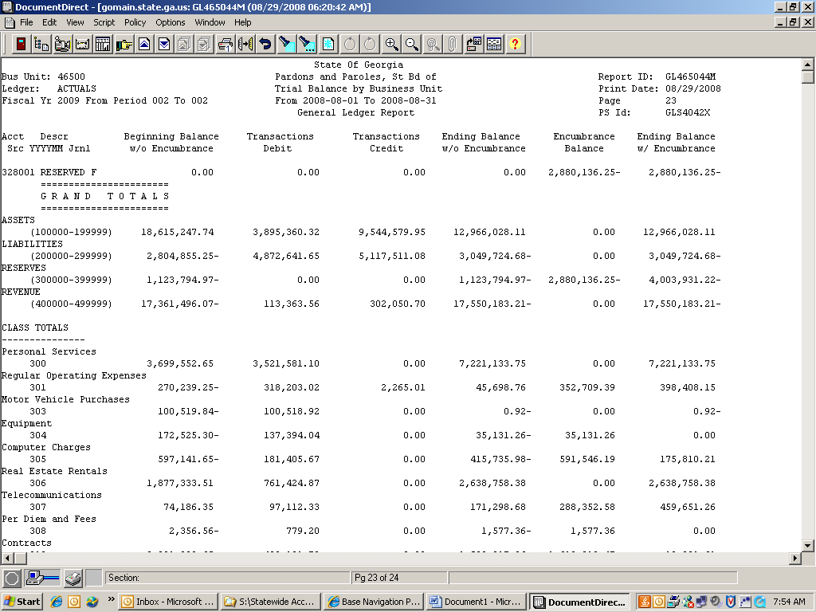
- Trial Balance Detail Report -- indicates a description of the report

Reconciliation Process

Compare Outstanding Encumbrance totals

STEP | SOURCE | ACTION
Step 1:  Run report and query the morning after month end close, prior to entering activities in the system. | GL###044M – GLS4042X | - Run report and query  - Confirm totals on both

STEP
SOURCE | ACTION
Step 2:  Run outstanding encumbrance detail report | GLS4071X -- GL###0471 | General Ledger > Custom GL Reports > PO Open Encumbrance or Purchasing > Purchase Orders > Reports > PO Open Encumbrance

Process Scheduler Request
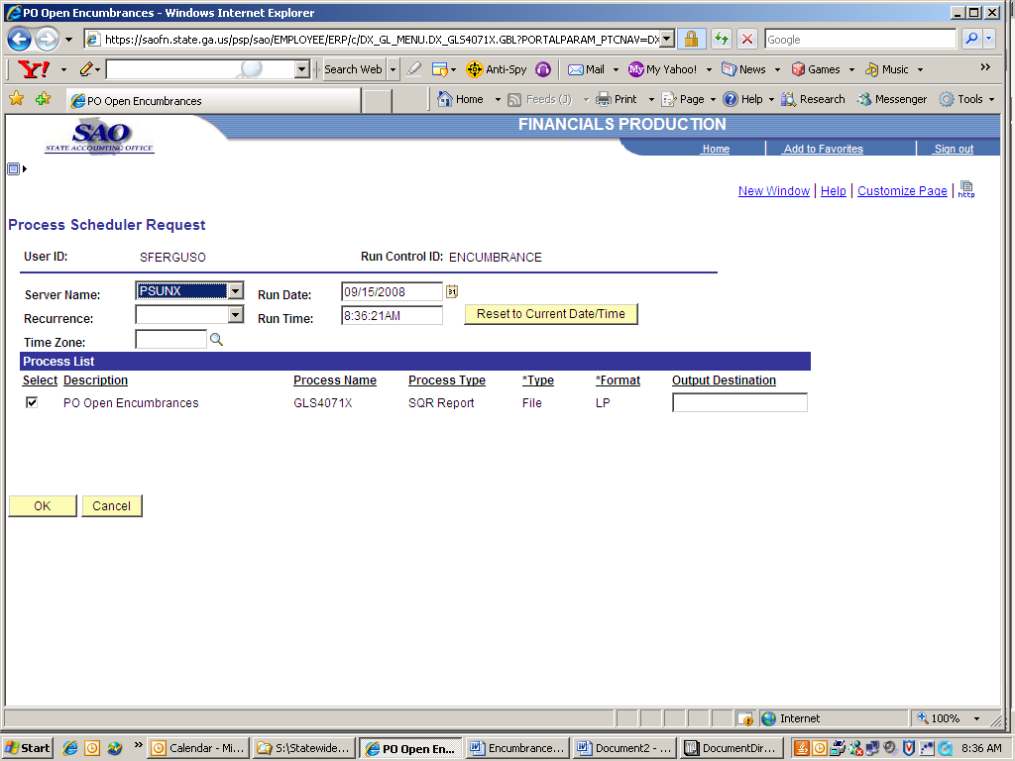
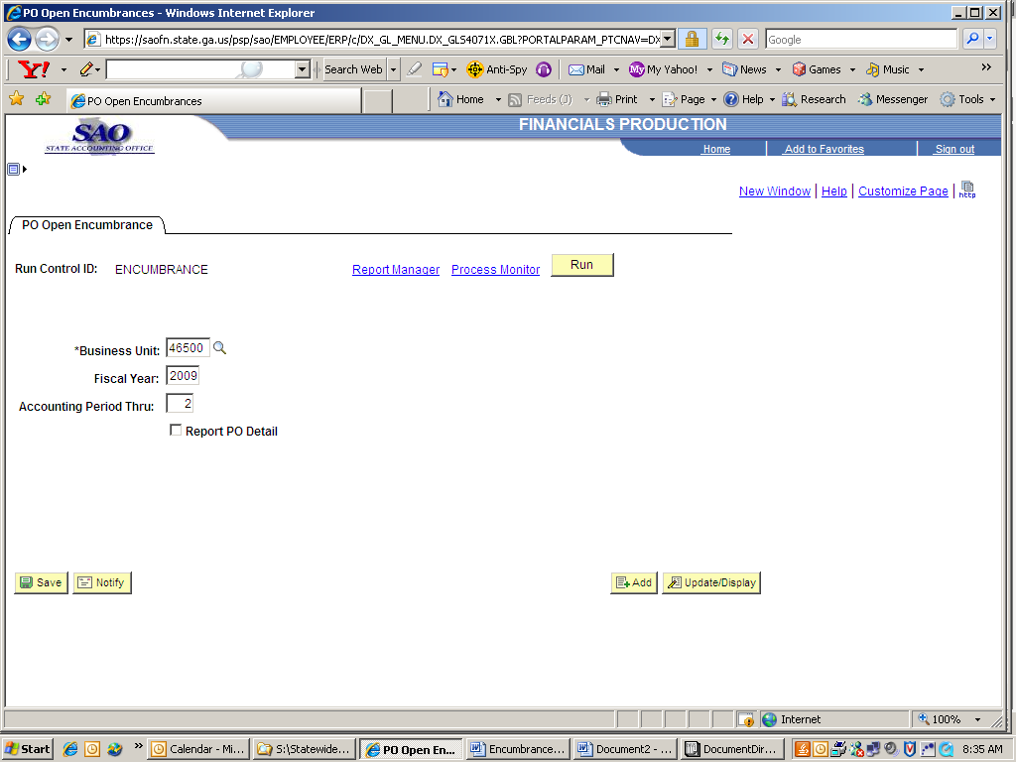
Do not check this box.
STEP | SOURCE | ACTION
Step 3:  Run Query | OPO013FP_ENC_THRU_FISCALPERIOD | Navigate to query viewer and run query

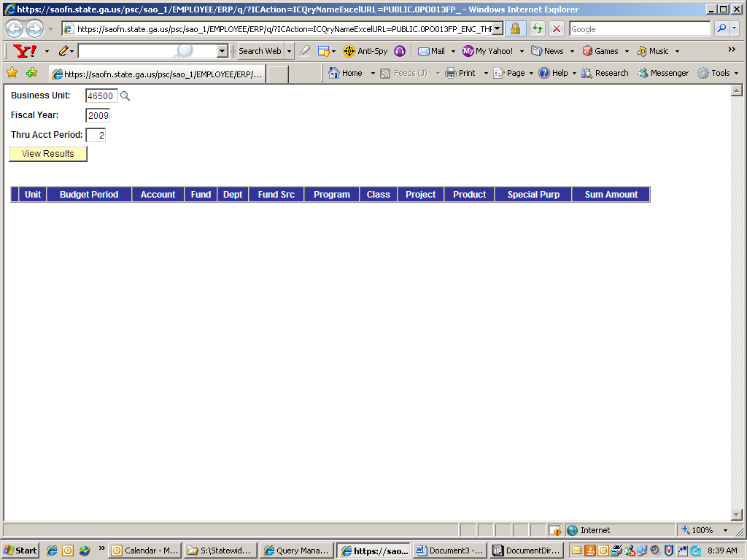

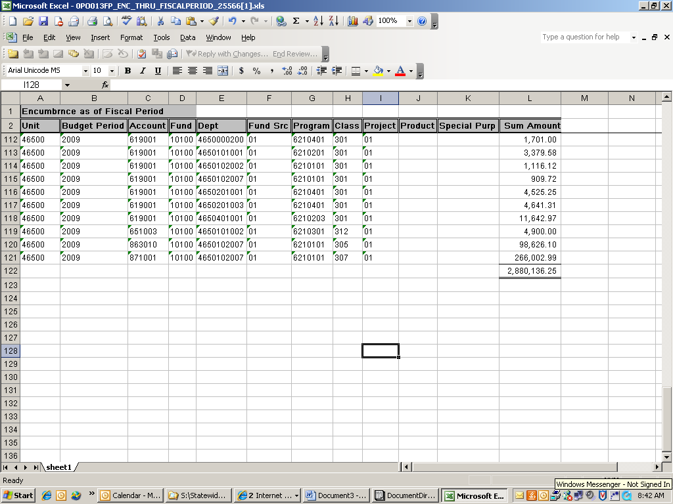
STEP | SOURCE | ACTION
Step 4:  Run query | 0PO045_GL_MAN_ENC_JRNL | Navigate to query viewer and run query

