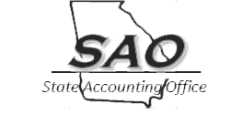
Statewide Business Process Policy & Procedure

Business Process Reference:  Section: Disbursements and Purchases  Title: Payment Process | Effective Date: 12/01/2016  Revision Date: 09/30/2022

Index:
Background
Business Policy Summary
Business Process Policy and Requirements
Monitoring
Authority
Applicability
Definitions
Forms and Attachments

Background:
As part of an effective system of internal controls, organizations must implement and follow procedures to ensure the proper purchase, through payment, of goods and services. Specifically, these procedures ensure that only approved purchases are made, that corresponding amounts are available in the budget and are approved prior to payment. Also, the State's to ensure these payments are made in the most efficient, effective, and least costly manner.

Business Policy Summary:
This policy is intended to provide organizations guidance relative to when a requisition or purchase order is expected in the procurement of goods and services, and procedures to ensure only valid and appropriate payments are being made in the most effective and efficient manner. Accordingly, the State of Georgia's goal is to eradicate paper, provide a secure payment method, and reduce costs by applying electronic payments to as many transactions as possible. Also, this policy provides guidance relating to one time payments, including usage of the SINGLEPAY1 vendor in TeamWorks.

Business Process Policy and Requirements:
Management in every organization is responsible to ensure an effective internal control system is in place and ensure policy requirements are being followed throughout the process relating to procurement to payment. These procedures should be formally documented and performed in a manner that is both effective and efficient. Specifically, organizations should implement procedures to ensure there is proper segregation of duties, verifying that payments for goods and services are for valid and legal purposes, and payments are approved and supported prior to payment. Additionally, any supporting documentation should be maintained for audit purposes.

However, in the case of emergency purchases, a slightly different procurement through payment processes may need to occur. Specifically, emergency purchases are needed items arising from unforeseen causes, including, but not limited to, extreme weather conditions or official declared emergencies. It should be noted that poor planning or the pending expiration of funds does not constitute a valid justification for an emergency purchase. Organizations should maintain any supporting documentation for decisions and justifications relating emergency purchases.

Internal Controls
Segregation of Duties
Duties should be segregated so that one individual is not able to perform all aspects of the procurement to payment process. Specifically, one individual should not be allowed to create requisitions or purchase orders, purchase goods or services, receive items, record payments in the accounting records, approve payments, and perform reconciliations. If duties are not able to be segregated, then appropriate mitigating controls should be implemented.

Valid and Legal purposes
Organizations must implement procedures to ensure that purchases and payments are made only for goods and services that are for valid and legal purposes. The organization should implement internal control procedures to ensure compliance with the Georgia Procurement Manual (GPM) and the Statewide Purchasing Card (P-card) policy. Also, there are numerous limitations specified in Federal and State laws and regulations, such as the Code of Federal Regulations (CFR), Official Code of Georgia Annotated (O.C.G.A.), Georgia Constitution, and Attorney General opinions that restrict items allowed to be paid. For example, payments for donations or gratuities, interest, late fees, and sales and use taxes are generally not a valid and legal purpose, and additional legal research should be performed prior to paying for these items.

Internal controls, such as use of requisitions and purchase orders, when applicable, should be used to verify procurement of goods and services are approved. Also, purchase orders restrict money in the budget by encumbering funds and are an important control to verify money is available in the budget. To be effective internal controls, requisitions and purchase orders should be issued prior to the purchase occurring.

Adequately Documented and Approved
Additionally, internal control procedures must be implemented by organizations to ensure that payments for goods and services are made for items that have actually been received and are supported by adequate and legitimate documentation. Procedures must also be established to ensure that payments are in accordance with terms and conditions of any agreements, such as purchase orders or contracts, and comply with terms such as, stated hourly rate, allowable services, and all other terms impacting the maximum amount to be paid allowed per the agreement.

Adequate Documentation: documentation, including original invoices and receiving documents, is required to support goods and services purchased and received. This documentation must contain certain key details, such as:
- Purchase Order, if applicable
- Original Invoices containing:
  - Vendor (payee) name and address
  - Organization name
  - Organization location that received goods or services
  - Dates items purchased or received
  - Itemized details such as:
    - Units and Quantity (weight, size, volume, etc.)
    - Unit price
    - Description of goods or services
  - Total Amount due
  - Approval for payment
- Receiving documents, such as delivery tickets, that itemize:
  - Delivery or received dates
  - Quantities
  - Unit Price
  - Locations
  - Employee who received items
  - Etc.

Legitimate Documentation: supporting documentation must be legitimate for the payment, and internal control procedures should be performed to verify:
- Appropriate vendor (not just a template or blank invoice).
- Appropriate shipping address or delivery location (for example, are the delivery location, building served, rent paid, etc. actually associated to the organization).
- Appropriate goods or services (are these items that the organization typically uses).
- Dates are within the appropriate fiscal year.
- Mathematical accuracy.
- Payment amount does not include prohibited items, such as taxes, interest or late payment fees.
- Employees or officials receiving goods or services and approving payments have authority to perform those duties.
- Payments are not duplicated (reviewing for duplicate dates, invoice numbers and amounts to the same vendor, not a billing statement or summary invoice, detailed invoices with unique invoice numbers).

Ideally, prior to payment, matching would be performed between the key supporting documents (invoice, purchase order and receiving report), specifically verifying certain details agree, including:
- Vendor (payee) name and address
- Quantities
- Unit Price
- Amount to be Paid

Requisition and Purchase Order Requirements
Organization management should implement internal control procedures, such as using requisitions, for amounts less than $2,500 to ensure that goods and services have actually been requested and approved prior to payment.

Furthermore, purchase orders are required in order to purchase goods and services greater than $2,500, excluding the following categories:
- Attorney and legal related payments, as such procurements are prescribed to the Department of Law via OCGA §45-15-34
- Benefit payments made directly to recipients
- Intergovernmental agreements/payments (e.g., Georgia Technology Authority (GTA) bills, Risk Management premiums, Human Resources Administration (HRA) assessments, etc.)
- Membership dues and/or subscriptions
- Payroll and associated tax and benefit payments
- Postage and shipping
- Certain Purchase card (P-card) transactions (see Payment Methods section for additional details)
- Real estate rental/lease payments
- Registration fees
- Sales and Use tax payments
- Travel expense reimbursements
- Utilities (e.g., electricity, telephone land lines, cell phone charges, etc.)
- WEX and ARI payments

Organizations may, at their discretion, use purchase orders for any of the above categories.

Payment Method Requirements
Organizations should make payments electronically to avoid the associated costs of issuing a paper check when practical. There are many advantages of electronic payments such as improvement to cash management by removing the uncertainty of check float, simplification of the bank account reconciliation process, and elimination of the check escheatment process. Also, there are numerous benefits to the receiver of electronic payments such as payments not getting lost or delayed, more confidentiality, and faster access to their money compared to check deposits. Furthermore, when organizations make a payment to a one-time vendor, such as a rebate or refund, the SINGLEPAY1 vendor ID could be used under certain circumstances. Organizations must determine the appropriate payment method by considering the following guidance, which is also displayed as decision trees in Attachment II.

State’s purchasing card (P-card)
- All purchases less than $5,000 may be paid utilizing the State’s P-card after following the GPM requirements, including obtaining an approved requisition prior to execution.
- Additionally, the P-card can be used in the following circumstances:
    - Unplanned, non-routine, or urgent purchases for less than $1,000:
      - These P-card transactions can be made either on-line or at point of sale (such as at the physical store) with a vendor and do not require a requisition prior to purchase.
      - However, these transactions are only authorized to be initiated by the employee whose name is shown on the face of the card and only for goods or services related to official State of Georgia business.

    - For emergency purchases the P-card policy allows organizations to pay for items utilizing the P-card, provided the state organization complies with specific requirements regarding after-the-fact requests for approval and documentation of such transactions. For example, reporting “emergency purchases,” as well as any other exceptions, such as exceeding single transaction and cycle limits would be reported to DOAS.
Non-P-card Vendor Payments
- Purchase orders and vouchers should be generated using the payment method consistent with this policy.
- Payments for goods and services, not paid for with the P-card, should be made via ACH and/or e-Payables.
  - If your organization’s bank has not yet been configured to accept ACH and/or e-Payables, your organization will not be considered to be in violation of this policy.
  - In order to assist with compliance with this policy, organization personnel can refer to the vendor master file for assistance. (Note: organizations not using TeamWorks should implement similar processes and controls to ensure that payments are made only to vendors and vendor locations which have been previously verified.)
  - TeamWorks vendors that have agreed to receive ACH payments from the State have “ACH-Primary” listed in location #000001 of the vendor master file.
  - TeamWorks vendors that have agreed to receive ePayables payments from the State have “EPAYABLES” listed in location #000999 of the vendor master file.
  - Accordingly, the payment method default for these TeamWorks vendors has been set to ACH or ePayables and payment by check is not expected.
- Payments to vendors by check should be done on an exception basis only.

One Time Payments
At times organizations need to make a payment to a one-time vendor without wanting to create and store the vendor in TeamWorks financials. The SINGLEPAY1 vendor ID can be used for refunds (original payment received via cash or check), rebates or one time transactions which are not 1099 applicable and are less than $600. All information including vendor name and address is manually entered on the voucher and payment will be made via check to the name and address entered.
However, SINGLEPAY1 should not be used for the following:
- Refunds for payment made via credit card.
- Vendors that already exist in the TeamWorks vendor master file.
- Payments to other state agencies.
- Payments to vendors that could be 1099 reportable.
- Payments that required a purchase order.
- Payments for goods and services originally encumbered on a purchase order.
- Payments for reimbursements to employees.

Wire Transfers
- Wire transfers are to be used only as a payment means of last resort since this option results in the highest cost and risk.
- Protocols for payment processing utilizing online bank proprietary systems must be implemented:
  - Bank proprietary system features need to allow organizations to assign authorization rights to execute wires to individual organization users.
  - Some key internal controls should also be in place, including:
    - A system administrator should be selected to set up users and grant their rights. More than one individual should be required to approve user rights (e.g. initiate payments, approve payments, approve templates, etc.).
    - The system administrator should NOT be granted wire transfer rights. An administrator may be used to approve payment requests.
- Dual Approval is preferred – one person within the organization initiates a wire transfer and another person approves the payment before it is released by the bank.
  - If dual approval is not utilized or there is not enough staff to segregate this system administrator, initiator, and approver roles, mitigating controls must be in place, such as:
    - Personnel initiating wire transfer should only be able to select from pre-authorized vendors and locations.
    - Vendors and wire requests should be approved by someone other than the person initiating the wire and preferably someone outside of the accounts payable department.
- Preauthorization:
  - Preauthorize wire limits - daily aggregate wire limits by organization and individual users should be established within the organization.
  - Preauthorize transaction limits - per wire transaction limits by individual users should also be defined.
- International wires should be prohibited by an organization unless management determines such wires are absolutely necessary.
  - Such prohibition can be easily implemented by restricting international wires in the bank proprietary system.
  - If international wires are allowed, there should be only specific individuals who are granted the ability to initiate or approve international wires (no single person should be allowed to both initiate and approve wires).
Employee Reimbursement Payments
  - If employees receive their regular salary payments via direct deposit/ACH, their reimbursement payments shall also be made via direct deposit/ACH.
  - If employees currently receive their regular salary payments by an alternative method, their reimbursement payments should be made via the same method.
    - Organizations should encourage employees receiving paper checks for payroll to receive expense reimbursement payments via direct deposit/ACH.

Monitoring
Organization management is responsible to ensure appropriate internal controls are in place and followed, including following procurement guidelines prior to payment. This monitoring should ensure purchases orders are being used as required and amounts paid are valid and legal. Also, management at the organization must ensure necessary approvals are being obtained, and verification of receipt of goods or services is occurring prior to disbursing funds. Organization personnel should never disburse funds if they are unsure whether these internal controls have been followed. Management of the organization is responsible to ensure monthly reconciliations are being performed timely and accurately, including resolution of any errors. Specifically, bank reconciliations are to be completed which compare the bank balance to the corresponding general ledger balance, and the P-card reconciliation comparing transactions to documentation. These reconciliations should be documented, clearly show the balances are in agreement, and include the details of all reconciling items. Also, Proper segregation of duties must be in place, or management must ensure mitigating controls are being performed, such as reviewing reconciliations, bank statements, P-card details, canceled check images, and supporting documentation. Some of this monitoring could be accomplished via TeamWorks queries or reports functionality.

Authority:
- Official Code of Georgia Annotated (O.C.G.A.) 50-5B-3 – Duties of the state accounting officer include:
  - Prescribing state-wide accounting policies, procedures, and practices;
  - Prescribing the manner in which disbursements shall be made by state government organizations;
  - Developing processes and systems to improve accountability and enhance efficiency for disbursement of funds and management of accounts payable;
  - Determining the proper classification for accounting and reporting purposes of all assets, liabilities, revenues, expenditures, fund balances, funds, and accounts in compliance with legal requirements and generally accepted accounting principles and prescribe a uniform classification of accounts and other accounting identifiers which shall be used by all state organizations.
- O.C.G.A. 50-5B-4(b) – Duties of the state agencies with respect to SAO.
  - All organizations of state government and all officers, agents, and employees thereof shall conform to and comply with the rules, regulations, policies, procedures, and forms devised, promulgated, and installed by the state accounting officer.
- O.C.G.A. 50-5-71. Emergency purchases authorized
- Applicable sections of the Georgia Constitution, such as:
  - Article III, Section VI, Paragraph VI Gratuities
    - Except as otherwise provided in the Constitution, (1) the General Assembly shall not have the power to grant any donation or gratuity or to forgive any debt or obligation owing to the public, and (2) the General Assembly shall not grant or authorize extra compensation to any public officer, agent, or contractor after the service has been rendered or the contract entered into.
- Applicable sections of the CFR, such as 2CFR200.317 Procurement for States
- Applicable Attorney General opinions

Applicability:
This business process applies to all Organizations included in the State of Georgia reporting entity. The term 'organization of state government' shall mean, without limitation, any agency, authority, department, institution, board, bureau, commission, committee, office, or instrumentality of the State of Georgia. Such term shall not include any entity of local government, including, but not limited to, a county, municipality, consolidated government, board of education, or local authority, or an instrumentality of any such entity. At these reporting organizations, all personnel with accounting and financial reporting responsibilities should be knowledgeable of this policy.

Definitions:
Electronic Payment– Secure payment made to a vendor using a banking process which eliminates the need to generate a paper check; e.g., ACH, P-cards, and wires.

e-Payables – Merchant card payment process specifically marketed and branded by Bank of America.

Purchasing Card (P-card) – Charge cards and commercial purchasing card accounts designed to enable authorized, permanent State of Georgia employees to make purchases of supplies, materials, equipment, and services for State business use, eliminating the administrative burdens and costs associated with traditional methods of payment. The State of Georgia P-card program is administered by the Georgia Department of Administrative Services (https://doas.ga.gov/).
Purchasing Order – A purchase order or PO is a contract between the state entity and the supplier. The purchase order is used for financial purposes to encumber funds. In addition, the purchase order may also be used to establish minimum contract terms. The terms, conditions, and specifications of the solicitation document and the award document will be incorporated into any contract between the state entity and the supplier as a result of the solicitation.

Requisition – A requisition generally refers to a document that identifies a purchasing need as well as certain key information identified on the requisition form.

Forms and Attachments:
- Attachment I: Sample Invoice and Billing Statement
- Attachment II: Payment Method Decision Trees

Attachment I – Sample Invoice and Billing Statement
Sample Invoice
Is the company name and address filled out (or generic)?
Company Name  Your Company Slogan  Street Address  City, ST ZIP Code  Phone: Phone Fax: Fax | INVOICE  Invoice # 100  Date: Date
Recipient Name  Is the recipient the organization?  Company Name  Street Address  City, ST ZIP Code  Phone: Phone | Ship To:  Is the date within the applicable fiscal year?  Is the ship to address associated with the organization?  Recipient Name  Company Name  Street Address  City, ST ZIP Code  Phone: Phone
Does the payee name match the vendor name?
QUANTITY | DESCRIPTION  Detailed | UNIT PRICE | TOTAL
150 | 500 pages of copy paper | 10 | $1,500
 | Office supplies |  | 10,000
Generic |  | Is the invoice itemized - listing details such as quantity, description of items, unit price, etc.?  Or does it have generic descriptions with lump sum dollar amounts?
 | SUBTOTAL | $11,500
 | SALES TAX  Is the total amount due properly calculated?  Does the amount due include taxes or late fees? | 120
 | SHIPPING & HANDLING | 15
 | TOTAL due | $110,635
Make all checks payable to Company Name
If you have any questions concerning this invoice, contact Name, Phone, Email
Thank you for your business!

Billing Statement
Notice this is a billing statement and not an original detailed invoice.

Company Name
Address: | Street Address |  | Phone: | Phone number
 | Address 2 |  | Fax: | Fax number
 | City, ST ZIP Code |  | Email: | Email address
Statement
Statement #: | Statement number |  | 10 | Bill To: | City Name
Date: | Date |  | 7/1/2020 |  | Company Name
Customer ID: | Customer ID |  | 12345 |  | Street Address
Address 2
Notice there is only reference to an invoice, but not the details of what was actually purchased.
Amount Past Due: |  | $10,000 |  |  | City, GA ZIP Code
Date |  | Invoice # |  | Amount | Payment | Balance
6/15/2020 |  | 10111 |  | $10,000 | $2,000 | $8,000
6/18/2020 |  | 10222 |  | $2,000 |  | $2,000
 |  |  |  |  | Total | $10,000
Reminder: Please include the statement number on your check.
Terms: Balance due in 30 days.
Payments should not be approved to be paid from only a billing statement.

Attachment II – Payment Method Decision Trees

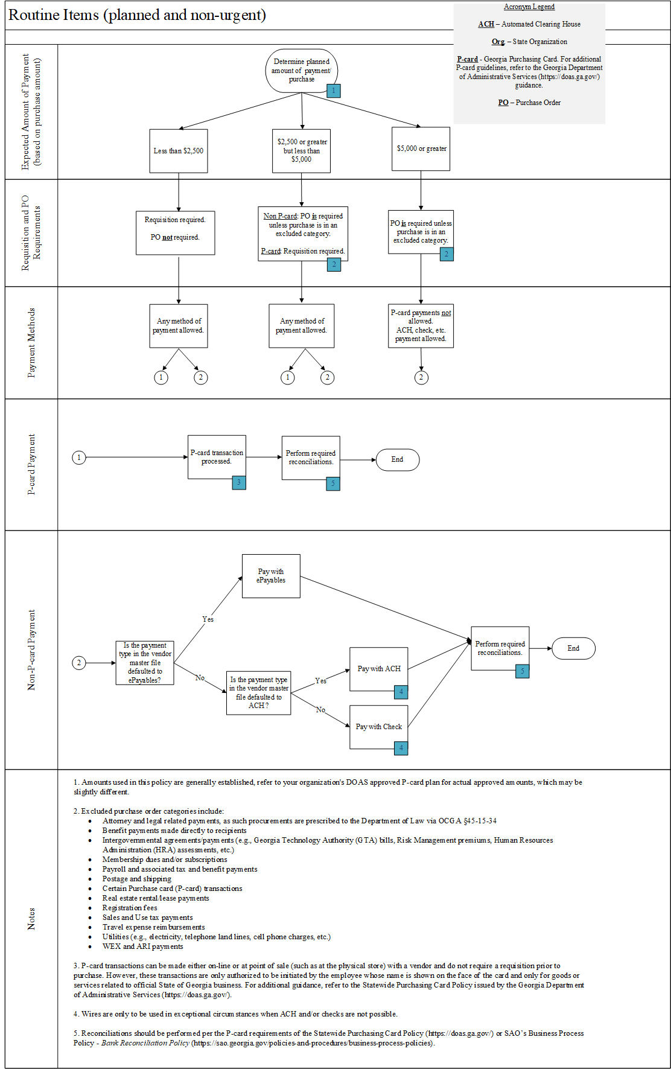

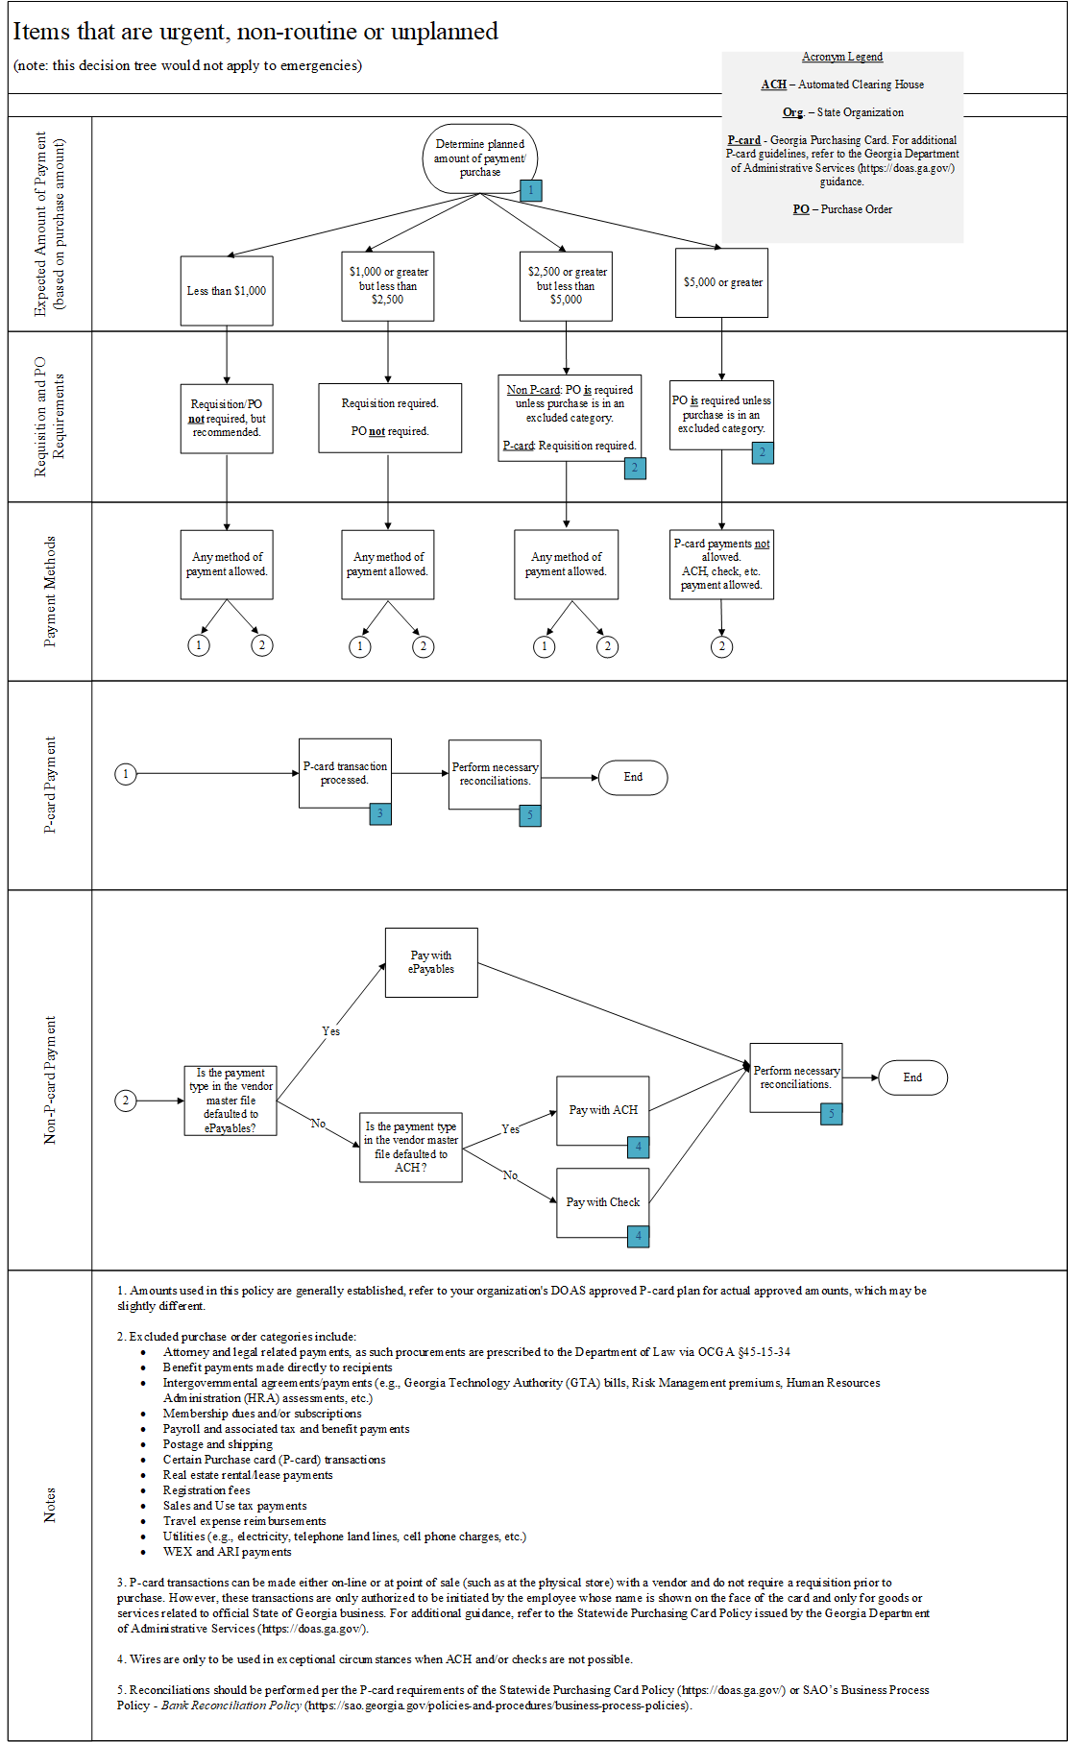

All organization contracts, statewide contracts, and interagency agreements should also be procured consistent with this policy and procurement guidelines issued by the Georgia Department of Administrative Services (https://doas.ga.gov/). Purchases and payments should not be split into numerous transactions to intentionally circumvent policy requirements.
For State of Georgia procurement and P-card guidelines, refer to the DOAS guidance (https://doas.ga.gov/).
See Attachment I for specific examples of key items to review on original documentation.
For State of Georgia procurement and P-card guidelines, refer to the DOAS guidance (https://doas.ga.gov/).
For additional details refer to State of Georgia P-card guidelines and DOAS guidance (https://doas.ga.gov/).

