Job Aid – Employee Readiness Activities for GA@WORK Go-Live

Table of Contents
Start here 1
Personal information updates in PeopleSoft/TeamWorks 2
Business, main, and mobile information review and updates in PeopleSoft/TeamWorks 3
Benefits Preparation 4
Expense Submission 4
Screenshots and downloads from PeopleSoft/TeamWorks 4
Time and Leave Preparation 5
Signing on to GA@WORK 6

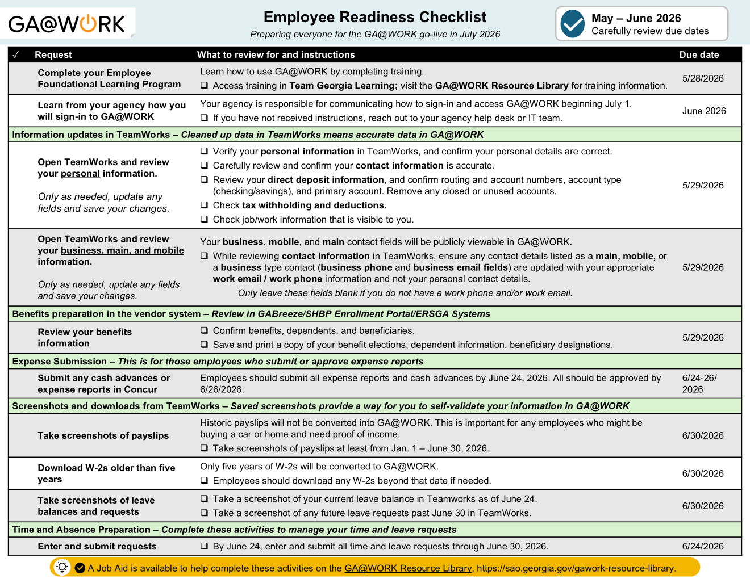

Start here
- Go to the different sections of this Job Aid to find instructions to complete the activities outlined on the Employee Readiness Activities for GA@WORK go-live checklist.
- Follow the instructions to complete the activities to get prepared for the go-live of GA@WORK.
- Each section has a due date when to complete these activities in red font.
- Ask your manager or your agency’s HR contact if you have any questions.

Personal information updates in PeopleSoft/TeamWorks
Navigate to your personal information page in PeopleSoft/TeamWorks:
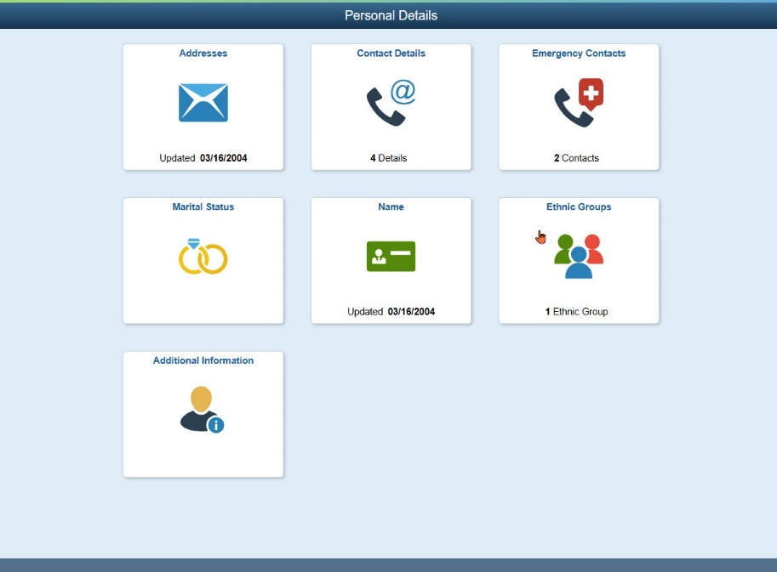
- Verify your personal information, and confirm your personal details are correct. This includes:
  - Your legal name, date of birth, and other personal details
  - Your personal email address and all phone numbers
  - Update as needed and Save each page you change
- Open your Direct Deposit/Pay Distribution page
  - Confirm routing and account numbers, account type, and primary account.
  - Remove closed/unused accounts, and Save any updates.
- Review your tax withholding (filing status and elections), if available in self-service.
  - Review any voluntary deductions that appear in self-service.
  - Save any changes you make.
COMPLETE THIS ACTIVITY BY MAY 29.

Business, main, and mobile information review and updates in PeopleSoft/TeamWorks
Your business, mobile, and main contact fields will be publicly viewable in GA@WORK.
- While reviewing contact information in TeamWorks, ensure any contact details listed as a mobile (mobile phone), main (main phone), and/or business type contact (business phone and business email fields) are updated with your appropriate work email / work phone information and not your personal contact details.
- Only leave these fields blank if you do not have a work phone and/or work email.
- It is important to review your contact information and confirm your personal email and phone are not listed as a business, main, or mobile contact. This information will be publicly visible on some transactions.
- GA@WORK users with these security roles should pay close attention when updating their contact information: Sourcing buyers, contract admins, PO buyers, and requestors.
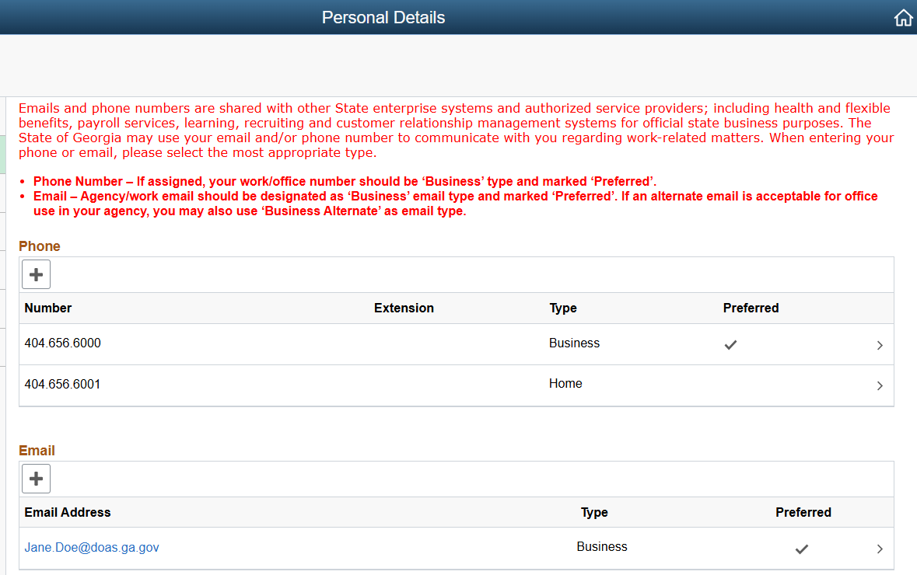
COMPLETE THIS ACTIVITY BY MAY 29.

Benefits Preparation
With your benefits provider, such as the State Health Benefit Plan, GABreeze, or others:
- Login
- Review your current benefit enrollments.
- Confirm dependents’ names, dates of birth, and relationships.
- Review beneficiary designations and percentages, and Save changes.
Save Your Benefits & Leave Information
- Save or print a copy of:
  - Current benefit elections and dependents
  - Beneficiary information
  - Current leave balances or other earnings/leave details you may want later
- Store these in your personal files for future reference.
COMPLETE THIS ACTIVITY BY MAY 29.

Expense Submission
- Employees should submit all expense reports and cash advances by June 24, 2026.
- All should be approved by June 26, 2026.
COMPLETE THIS ACTIVITY BY THE INDICATED DATES.

Screenshots and downloads from PeopleSoft/TeamWorks
Screenshots provide a way for employees to self-validate that their information successfully moved from PeopleSoft/TeamWorks to GA@WORK. Ask your manager or search online if you’re not sure how to create a screenshot. You’re recommended to save screenshots to your computer in a location you will be able to easily find them again after July 2026.
- Download or print recent pay stubs you may need for:
  - Loans or housing applications
  - Income verification or personal records
  - Do this before you lose access to PeopleSoft.
- Download or print any available tax forms (e.g., W-2s, other tax documents).
  - Keep copies for your personal tax and financial records.
  - Complete this step before access to PeopleSoft changes.
COMPLETE THIS ACTIVITY BY JUNE 30.

Time and Leave Preparation
Only time and leave requests submitted through June 30 and approved by June 24 will be converted to GA@WORK. After June 24, access to PeopleSoft/TeamWorks will be made Read Only and users will not be able to make updates. Submitting and approving time and leave requests before the deadlines below ensures your leave balances will be accurate in the new system.
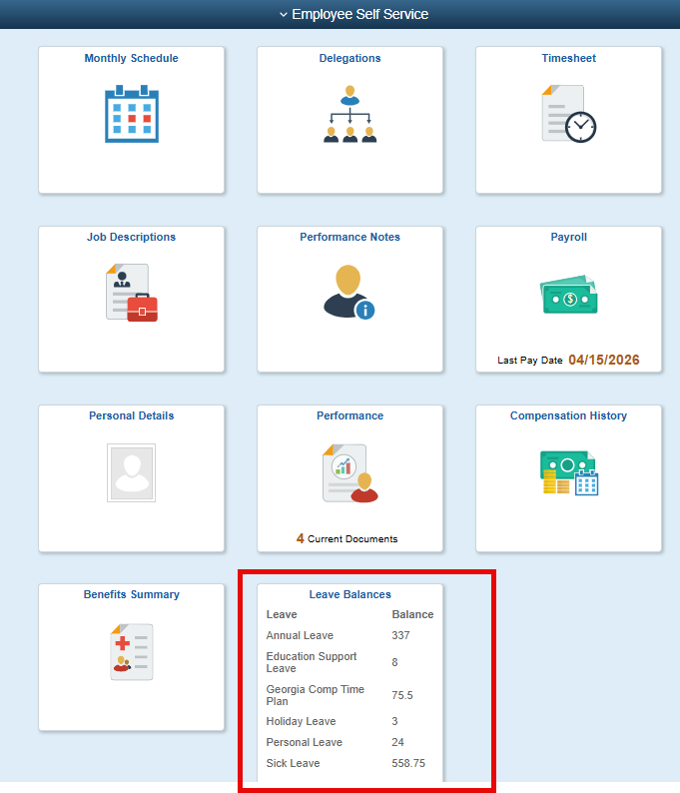
All Employees (Including Managers):
- Enter and submit all time and leave requests through June 30 by June 24.
- Take a screenshot of your current leave balance in PeopleSoft/TeamWorks by June 24, and save it to validate it once you have access to GA@WORK.
  - Recommend taking a screenshot and saving it to your desktop.
- Take a screenshot of any future leave requests past June 30 in PeopleSoft/TeamWorks by June 24
  - Recommend taking a screenshot and saving it to your desktop
Time Approvers: Approve all time submissions and pending leave requests by June 24.
After July 1, re-enter any future leave requests past June 30 in GA@WORK that were entered in PeopleSoft/TeamWorks.
COMPLETE THIS ACTIVITY BY JUNE 30.

Signing on to GA@WORK
Your agency is responsible to communicate to you how to sign-in and access GA@WORK beginning July 1. If you have not received instructions about how you will sign into GA@WORK, reach out to your agency help desk or IT team.
Job Aids for how to sign on are available on the GA@WORK Resource Library.
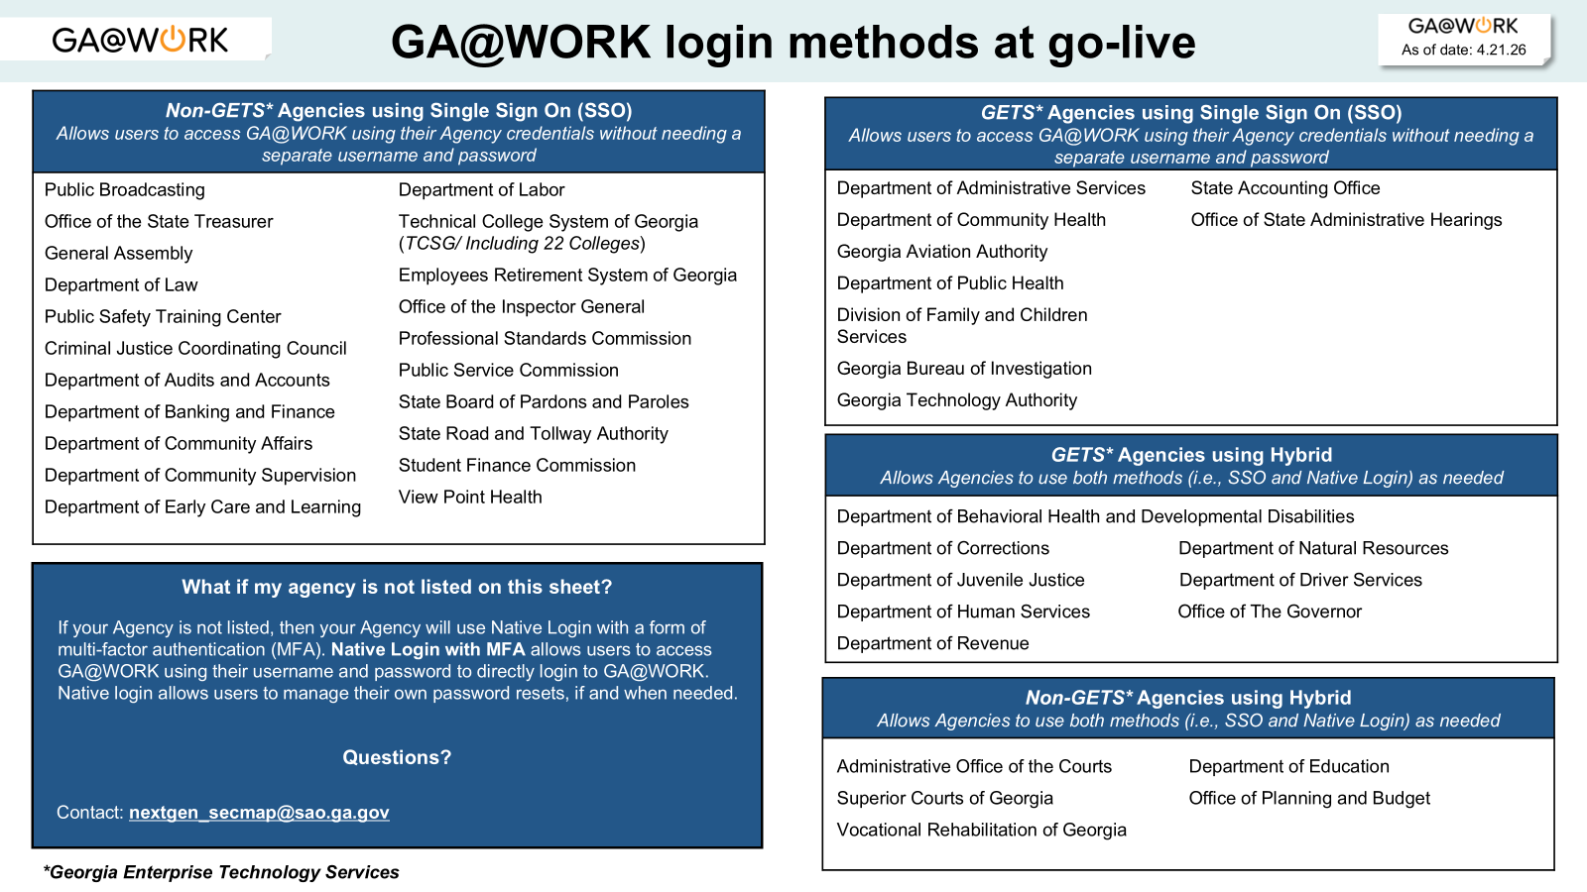
YOU SHOULD KNOW HOW TO SIGN-ON TO GA@WORK BY JUNE 2026.

