Fiscal year end adjustment journal procedures

Each fiscal year end after period 12 is closed, an adjustment period, also known as period 998, is opened for state agencies. Agencies may use this adjustment period to post final GL journals. When period 12 is closed, all submodules are closed and only journals may be entered into the general ledger.

When entering an adjustment gl journal, the users must use a specific combination of journal date, accounting period and fiscal year.
In the enclosed procedures/example, the user will create an adjustment period journal for fiscal year 2021.

Navigation path: General Ledger>Journals>Journal Entries>Create/Update Journal Entries
- Create a new journal by clicking on the “Add a new value”. Enter the appropriate business unit, journal id, and use a journal date of 06/30/202X. Click “Add”.

*Important note: Teamworks will default the journal date to the current date, it is extremely important for users to override the defaulted date to a date of 06/30/202X for period 998 journals. Period 998 journals can not be created with a July journal date. Any period 998 journal with a July journal date will need to be reversed, and re-entered.
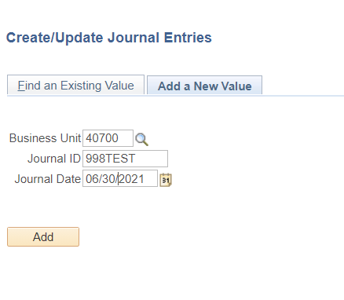
- Enter a description and change the adjusting entry type from “Non-Adjusting Entry” to “Adjusting Entry”.
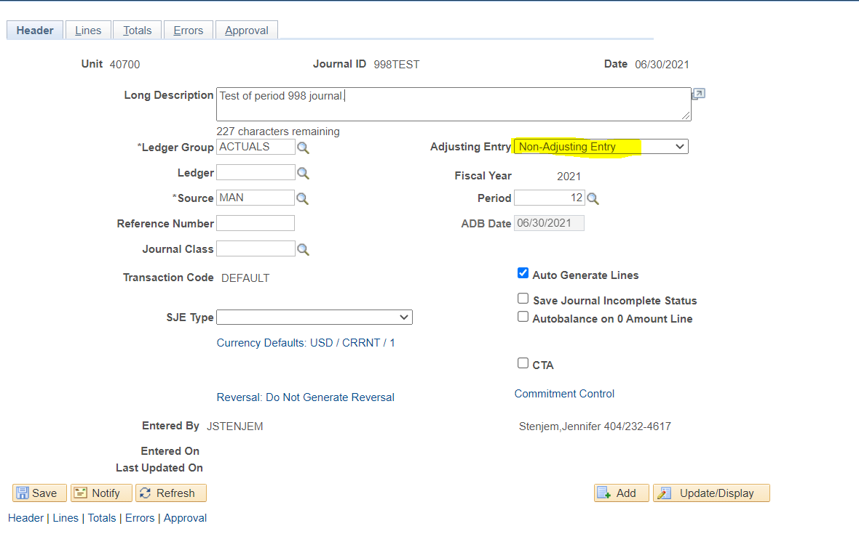
- Note, when the adjusting entry type is changed to “adjusting entry”, the accounting period will change from 12 to 998.
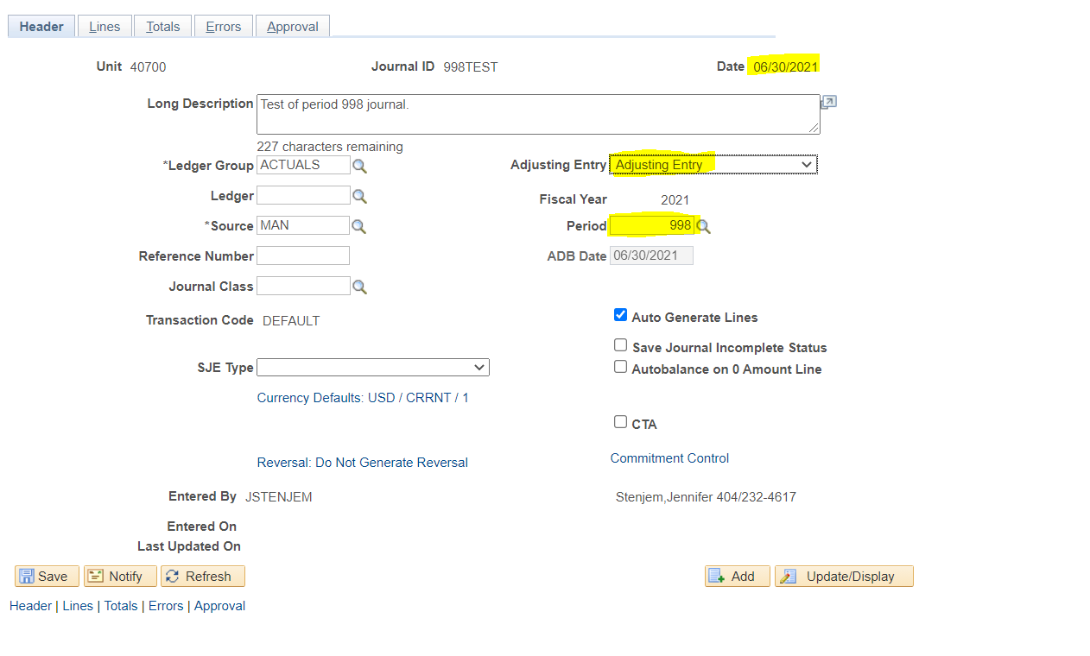
** Important note: During the adjustment period, the appropriate combination for period 998 entries is a journal date of 06/30/202X, period 998, and the fiscal year which is being closed.

- Navigate to the journal line tab and enter the appropriate journal information. Save the journal.
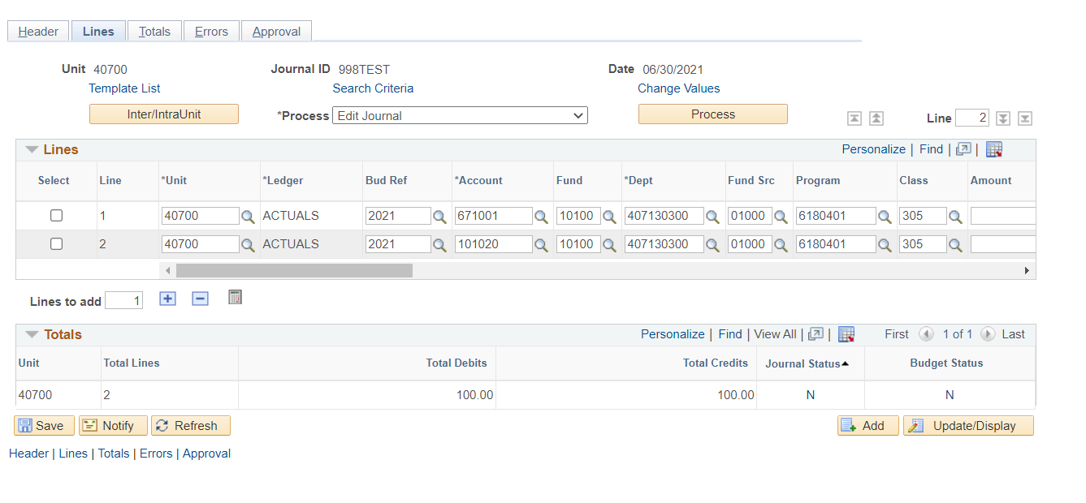

During the adjustment period, it is recommended that users edit, budget check and post their journals to ensure the journal posts in a timely manner.

Please direct any questions, comments or concerns to the Customer Service Center.

